|  |  |
| --- | --- |
| 0 | EUROPEAN COMMISSION  DIRECTORATE-GENERAL FOR HUMANITARIAN AID - ECHO |

**SINGLE FORM FOR HUMANITARIAN AID ACTIONS[1]**

# GENERAL INFORMATION.

## Name of Humanitarian Organisation/Country of registration:

United Nations Development Programme (UNDP) in Honduras

## Title of the Action:

Building resilient communities to landslides, earth wakes and floods in the municipalities of Marale and Yorito.

## Area of intervention (country, region, localities):

Honduras, C.A. Marale Municipality, Francisco Morazan Province and Yorito Municipality, Yoro Province.

## Start date of the Action:

October 1st, 2008.

## Duration of the Action in months:

15 months

## Start date for eligibility of expenditure:

October 1st, 2008.

## Requested funding modalities for this agreement

100% financing 🞎  
Co-financing 🞎  
Multi-donor (for International Organisations) 🗹  
In case of 100% financing: justify the request

## Urgent action Yes 🞎 No 🗹

If yes: ECHO Primary emergency decision 🞎  
 ECHO Emergency decision 🞎  
 Other ECHO decision 🞎 Please justify:

## Control mechanism to be applied: A 🞎 P 🗹

## Proposal and reports

Initial proposal 🗹 date: 30-04-08  
Revised proposal N°3 🗹 date: 10-09-08  
ECHO reference A/… date: dd-mm-yy  
Intermediate report 🗹 date: 30-05-09  
Final report 🞎 date dd-mm-yy

## [INT] List the supplementary agreements and exchange of letters after signature of the Agreement up to intermediate report stage

Three letters where exchanged:

1. Revision of budget, activity plan and organization chart, as a result of the first monitoring visit.
2. Request of approval for financing some aspects of a training.
3. Request of approval for the submission of budget in UNDP format.

## [FIN] List the supplementary agreements and exchange of letters after submission of the Intermediate report up to final report stage

# NEEDS ASSESSMENT.

## Date(s) of assessment; methodology and sources of information used; organisation/person(s) responsible for the assessment.

Needs assessment was carried out during March and April 2008 by Ginés Suárez Director of Fundación “San Alonso Rodríguez” (FSAR), Juan Jose Ferrando, UNDP Programme Officer and Orlando Lara Pineda, Consultant. A field team of FSAR comprising a sociologist, a geologist and an environment technician was in charge of a baseline study and additional primary data collection.

Sources of information:

1. Review of secondary data including UNDP Human Development Report for Honduras (2006), Honduras Population Census 2001 of National Institute of Statistics (INE) Government of Honduras (GoH), Land management plan of Marale and Yorito municipalities elaborated by PBPR (Project Forest and Rural Productivity) of World Bank, Socioeconomic and Productive diagnostic developed by PRONADEL (Local Development National Programme) of the Ministry of Agriculture; an earth wake hazard/vulnerability diagnostic prepared by Universidad Nacional Autonoma de Honduras (UNAH) at Marale Municipality, fieldwork by students from UNAH Master on Risk Management and data and maps of the National Territorial Information System (SINIT) of the GoH.
2. Information gathered by UNDP´s implementing partner, the Foundation “San Alonso Rodriguez” (FSAR) that is currently implementing a project of reconstruction with local materials in the communities affected by the earthquake of September 15th 2007 with close contact with local stakeholders.
3. Meetings with Marale and Yorito municipalities to discuss project proposal and carry out a survey on Municipal Emergency Committees (CODEMs) capacities and structure.
4. Selection of the most vulnerable communities in both municipalities analyzing secondary data and implementing participative discussion processes. 38 communities, 19 communities in each municipality, were selected.
5. A baseline study was carried out in selected communities to determine the different levels of community resilience including participatory surveys and statistical analysis of data collected.

## Problem statement and stakeholder analysis.

Hazards

* Municipalities of Marale and Yorito are located nearby Yoro Mountain in a very isolated area in the centre of Honduras. Both municipalities have high vulnerability levels, low-medium development rates[2] and high poverty levels (51.2% in Marale and 34% in Yorito). The majority of Tolupan population - one of the most excluded and marginalized ethnic minority- lives in this area.
* There is a high landslide hazard in the area due to geomorphologic characteristics, steep gradients, continuing deforestation and faults. 31% of Marale Municipality (12,642 ha) is under landslide hazard and 92% of this area (11,589 has) has high landslide hazard. In Yorito Municipality the landslides hazard area represents 25% of municipality area. 3,769 has are in high hazard. Rains (precipitations) and earth wakes act as unleashing factors. Interviews during field visits confirmed that landslides take place every year during the rainy season while other landslides occurred during the earthquake. According to USGS studies and local information gathered 18 communities (12 in Marale and 6 in Yorito) are in high landslides hazard levels and 10 communities in Yorito are in middle landslides hazard level.
* Besides, there is a high floods hazard in certain areas linked to high annual and daily rainfall rates (1300 mm with maximum of 75 mm per 24 h). Yorito and Marale municipalities have an extended hydrological network. Mountain Rivers that during storms have sudden increases. Communities placed close to rivers are in high risk of floods. 21% of Yorito Municipality (5,561 has) is under high floods hazard and 12% (4,916 has) of Marale Municipality. According to USGS studies and local information gathered 11 communities (9 in Marale and 2 in Yorito) are in high floods hazard levels and 6 communities (2 in Marale and 4 in Yorito) are in middle floods hazard levels.

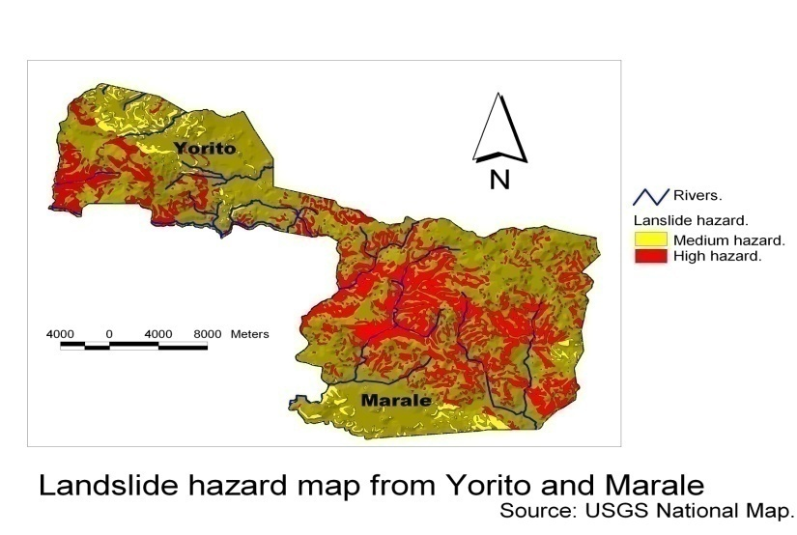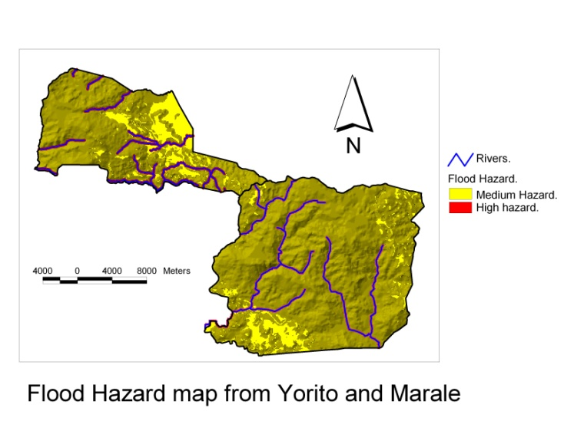

* Awareness of hazard has changed dramatically since a 5.5. Magnitude earthquake affected the area on September 15th 2007. 192 houses were destroyed (125 in Marale and 67 in Yorito) and 315 have important damages (207 in Marale and 108 in Yorito). This was the biggest earthquake in Honduras recent history and demonstrated the low response capacities to earthquakes in the country. The evaluation undertaken by UNAH showed that high vulnerability was the main cause of the high impact of the earthquake. Seismic, landslide and flood hazards overlapped with high vulnerability levels to produce the disaster. Six months after the earthquake there is not yet a clear identification of the seismic hazard in Marale and Yorito. There are not earth wake hazard maps elaborated in Marale and Yorito Municipalities. A country seismic hazard map exists but it does not have the required details for a municipal analysis and actions. September 15th earth wake showed the great deficiencies in knowledge of seismic hazard in Honduras due to lack of appropriate measurement tools and trained personnel capable to analyze the information. There are only available reports elaborated by UNAH Risk Management Master Degree Program towards a preliminary characterization of the existent seismic hazard that can not been assumed as conclusive. These reports identified “a priori” than it seems that there is not a “site effect”. Thus, an amplification effect of seismic waves has not been identified, due to subsoil characteristics. That may imply – preliminary- that distances to active faults to earth wakes “epicentres” will be the source to define higher o lower hazard exposure of different sites. Therefore, identifying these faults is a priority. There is a first identification of a fault that could have produced the earth wake along Siguapa River but this is still pending to be verified. Preliminary estimations are of a middle seismic hazard in both municipalities with some specific sites with high hazard corresponding with the most affected by the September 15th earth wake including 6 communities in Marale Municipality and 5 in Yorito Municipality. See annex 1 with base line study.

Vulnerabilities

* Communities in Marale and Yorito Municipalities are exposed to high levels of vulnerability. Chart 1 summarizes estimations on physic, economic and educational vulnerability.

**Chart 1: Communities affected by Vulnerability in Marale and Yorito Municipality**

|  |  |  |  |
| --- | --- | --- | --- |
| **Municipality** | **High Physic vulnerability** | **High Economic vulnerability** | **Illiteracy/ Education Vulnerability** |
| Marale | 95% | 75% | 50% |
| Yorito | 94% | 73% | 30% |

* More over, cultural-ideological vulnerability is linked to absence of understanding of earth wakes that generates panic in population and the lost of traditional construction techniques reducing adequate maintenance to adobe built houses.
* Organizational vulnerability is very high in communities as Local Emergency Committees (CODELs) have not been organized as well as high institutional vulnerability as Municipal Emergency Committees (CODEMs) are not properly trained and offices of COPECO - national emergency response authority- are more than 140 km distance reducing real support and response during emergencies. Both Yorito and Marale do not have fire fighters or Red Cross rescue teams.

Resilience Levels

* Communities in both municipalities have the lowest resilience levels in terms of: Governance, Risk assessment, Knowledge and education, Risk management and vulnerability reduction and Disaster preparedness and response.

**Stakeholder analysis**

* Except for emergency response actions by COPECO, after September 15th earth wake, there has not been any interventions on emergency preparedness in Marale and Yorito Municipalities. Currently COPECO is training Marale CODEM and two CODELs (La Union and Playa Grande communities). However, hazard maps will not be elaborated thus the Project intends to complement local training efforts. Meanwhile, Yorito CODEM has been created but not trained yet and it is expected that CIPE - a consultancy firm - will start a training process under coordination with UNDP and FSAR.
* Practically there are not NGO or other development private institutions in Marale Municipality. The international NGO World Vision and FIPAH, Fundación Hondureña para la Investigación Participativa (Honduran Foundation for Participatory Research) have projects in Yorito Municipality supporting formal education and agriculture.
* The Ministry of Agriculture (SAG in Spanish) implements projects towards production improvement.
* PRAF a National Household Support Program targeting poor families is operating in the communities.
* Fundación “San Alonso Rodríguez” (FSAR) is a national NGO – implementing partner in this project – that started to work in the area (Yorito and Marale municipalities) evaluating damages and effects caused by September 15th earth wake jointly with UNAH and COPECO staff. Afterwards, rebuilding activities were supported as part of a national initiative on house reconstruction based in adobe materials fostered by FSAR since 2002 with financial support from the German NGO MISEREOR. Currently two pilot houses are under construction based on adobe as the main input material using an adobe technique. These houses will be used as models for the local process of reconstruction. At the same time organization and training actions of Yorito CODEM have started with direct support from FSAR and UNDP. These activities will be followed up by the project.
* Municipalities started reallocation of affected population without considering risk information. First problems emerged when an evaluation carried out by UNAH Risk Management Master Degree Program showed that land purchased by Marale Municipality to reallocate the population affected by the earth wake had high landslide and flood hazard levels (See annex 1). Moreover, lack of local information and knowledge on earth wake hazard creates a situation of panic and uncertainty. Emergency preparedness capacities are very low as Local Emergency Committees (CODELs) have not been created and Municipal Emergency Committees (CODEMs) have practical experience but not training. Current situation in 38 communities identified is of high risk as economic and physic vulnerability corresponds with a multi hazard scenario of landslides, earth wakes and floods.

## Summarise findings of the assessment (include full report in annex, if relevant) and link these to the Action.

38 communities (29 communities with very high and 9 with high risk to natural hazards) were identified in Yorito and Marale. These hazards are landslides, floods and seismic hazard. The communities are located in inaccessible areas, without local, municipal or regional level organisation, without floods or landslides EWS, very low resilience levels and high vulnerability levels. Therefore, a variety of disaster preparedness, mitigation and prevention measures are proposed to reduce the risks that affect these communities:

* Prevention measures: Carry out an education campaign aiming to raise awareness in the population of the need to protect the forest coverage in areas of steep gradient and to avoid the construction of houses in risk zones. Prevention campaign will include promotion of construction techniques based on indigenous knowledge to reduce households’ physical vulnerability.
* Preparedness measures: Organise and train community and municipal emergency committees in disaster preparedness and response techniques, including installation of communication systems and EWS. Disaster preparedness actions comprise provision of shelters infrastructure for isolated communities, improvement of evacuation routes and provision of basic emergency items.
* Mitigation measures: Implement pilot mitigation projects to reduce effect of landslides and floods including soil conservation and reforestation.
* Institutional support: The project will complement capacity building efforts for CODEMs including training.
* Emergency response capacities: The project will strengthen national capacities of COPECO and UNAH as well as Instituto Nicaraguense de Estudios Territoriales (INETER) of Nicaragua; through training and equipment. Furthermore, networking and alliances among COPECO, UNAH and INETER and Mexican institutions and scientists will be strengthened for periodical monitoring and evaluation of seismic hazard.

## . [INT] If changes in needs assessment at intermediate report stage, please explain

No changes in needs assessments at this stage.

## [FIN] If changes in needs assessment after intermediate report, please explain

# HUMANITARIAN ORGANISATION IN THE AREA OF INTERVENTION.

## Humanitarian Organisation's presence in the area of intervention: brief overview of strategy and current or recent activities in the country

UNDP has been supporting COPECO through emergency response projects targeting institutional strengthening, improving communication systems, equipping and training Centres of Emergency Operation in each COPECO sub-national office and facilitating key coordination between COPECO and CODEMs in municipalities. Moreover, UNDP has enhanced the UN system response capacity including implementation of cabinet drills and protocols coordinated with COPECO. UNDP has supported actively the revision and advocacy to pass the law of the National System of Risk Management (SINEGER) facilitating dialogue among civil society and government.

## Actions currently on-going and funding requests submitted to other donors (including other EC services) in the same area of intervention - indicate how overlap and double funding would be avoided

UNDP has been supporting reconstruction and disaster preparedness capacities in the September 15th earth wake area. Currently UNDP is executing actions with regular funds in the first steps of organizations and structuring of CODEMs in both municipalities and facilitating coordination among UN agencies in Honduras, government ministries and international and national NGOs.

## [FIN] List other Actions carried out by the Humanitarian Organisation or its Implementing Partners in the same period in that area of intervention and how risks for double funding were avoided.

# OPERATIONAL FRAMEWORK.

## Exact location of the Action (include map of project location)

## The project is located in the centre of Honduras in the municipalities of Yorito, Yoro Province and Marale, Francisco Morazán Province. See map in annex 2.

## Beneficiaries

### Total number of direct beneficiaries:

16,722 will be direct beneficiaries including 16,532 (70% of Yorito and Marale population) and 190 participants in national and regional training, advocacy meetings and scientific experts forums.

### Status of the direct beneficiaries (multiple options possible) 🞎 IDPs 🞎 Refugees 🞎Returnees 🗹 local population 🗹 others (Participants in training and scientific forums)

### Specificities of direct beneficiaries (please elaborate; refer to groups as appropriate, e.g. unaccompanied minors, disabled, children, ex-combatants….

|  |  |
| --- | --- |
| Men | 8,420 |
| Women | 8,112 |
| Tolupan ethnic members | 664 |
| Handicapped | 133 |
| Children | 5,949 |
| Elders | 951 |
| Participants in training, advocacy meetings and scientific experts forums | 190 |

### Direct beneficiary identification mechanisms and criteria

Direct beneficiaries were identified through a risk analysis carried out at community level in both municipalities. Beneficiaries’ identification mechanism included a first selection by FSAR personnel and participatory validation thourgh local meetings in each municipality. Economic vulnerability levels were estimated considering houses materials and economic vulnerability levels were estimated considering poverty line at community level. Hazard levels considered landslides and earthquakes hazards were estimated accoding to data from the National System of Territorial Information (SINIT). Hazard and vulnerability levels were used to estimate levels of risk and select those communities with a higher level.The list of communities was finally discussed and agreed with local governments. (See detailed methodology and list in annex 3)

### Describe to what extent and how the direct beneficiaries were involved in the design of the Action.

In all communities selected local perception of risk was analyzed as well as mitigation and emergency response actions that local population considered more appropriate. Local governments, COPECO officials and UNAH researchers were consulted.

### Other potential beneficiaries (indirect, "catchment", etc.)

23,617 (total population) in the municipalities of Marale and Yorito will be indirectly benefited from CODEMs strengthening, education efforts and awareness activities.

### Direct beneficiaries per sector:

|  |  |
| --- | --- |
| **Sector** | **Number of beneficiaries** |
| 1. Local disaster management. | 10,189 beneficiaries; 5,160 men, 5,023 women. 317 tolupans, 3,570 children, 641 elders and 75 handicapped. |
| 2. Institutional linkages and advocacy. | 190 directly benefited. 25 persons trained, 20 persons participating in advocacy meetings and 50 persons participating in scientific experts forums. |
| 3. Information, education, communication. | 16,532 beneficiaries. 664 tolupans, 133 handicapped, 5,949 children and 951 elders. |
| 4. Small scale infrastructure and services. | 5,094 beneficiaries; 2,580 men and 2,514 women. 159 tolupans, 1,785 children, 320 elders and 38 handicapped. |
| 5. Stock building of emergency and relief items. | 5,000 persons according to an estimation of population that might be affected in an earth wake scenario in Yorito and Marale. |

### [INT] In case of changes, please explain

No changes at this stage.

### [FIN] In case of changes, please explain

### [FIN] Estimate per type of beneficiaries

female: … %, male: … % (total female + male= 100%)  
infants (< 5y): … %, children (< 18 y): … %, elderly: … %

## Objectives, Results and Activities

### Operational Overview of the Action: Log-frame[3] (max. 3 pages).

|  |  |  |  |  |
| --- | --- | --- | --- | --- |
| Title of the Action | Building communities resilient to landslides, earth wakes and floods in the municipalities of Marale and Yorito. | | | |
| Principal Objective | Reduced risk by improving the preparedness capacities in the most vulnerable communities of the municipalities of Marale and Yorito in Honduras, CA. | | | |
|  | Intervention Logic | Objectively Verifiable Indicators | Sources of Verification | Risks and Assumptions |
| Specific Objective | Improve the resilience and response capacities of communities and Municipal governments to earthquake, floods and landslide hazards in Marale and Yorito. | At the end of the project 60% of population, including children, have DP knowledge and capacities for a higher level of resilience in case of an emergency.  At the end of the project 80% of local structures and government members have DP knowledge and capacities to respond to an emergency  At the end of the project 100% of local structures equipped for a higher level of response to an emergency | Emergency Plan Documents  Drill reports  Buying Equipment bills  Progress reports  Final Report  KAP reports  Local/national statistics | Risk: The occurrence of a disaster that deepens vulnerability during project execution.  Assumptions: Adequate levels of coordination of project with municipalities, COPECO, UNAH, INETER and UNAM. |
| Results | 1. 38 communities in the municipalities of Marale and Yorito and 2 municipal governments (Marale and Yorito) have community and municipal emergency committees created and functioning (according to COPECO norms), EWS for floods and landslides installed and operating.  2. Strengthened national emergency preparedness and response capacities for earthquakes.  3. Population of 38 communities in the Municipalities of Marale and Yorito educated about and more aware of, risk of earthquakes, floods and landslides and CODEM/CODEL share methodologies and research results with national/regional key actors.  4. At least 12 communities in the municipalities of Marale and Yorito reduced their vulnerability to natural disasters through small demonstration mitigation and infrastructure support projects  5. Reinforced local first response capacity in the municipalities of Yorito and Marale. | 1.1 36 local Emergency committees organized & trained,  1.2 2 local and 2 municipal emergency committees strengthened,  1.3 37 contingency plans and risk maps developed (36 at community level and 1 at municipal level),  1.4 1 municipal emergency plan updated.  1.5 2 EWS and communication systems installed and working.  1.6 Two (2) municipal practical drills carried out.  2.1 20 staff members of COPECO and institutions of the Emergency system and 5 volunteers from UNAH trained in seismic hazard.  2.2. COPECO and UNAH equipped each with 3 seismometer and geophysics refraction equipment.  3.1 12 month radio advertisements on floods, earthquakes and landslides transmitted;  3.2. Education and publicity materials distributed throughout the municipalities  3.3. Children from 38 schools and 315 high vulnerable families trained.  3.4 1 methodology for local risk evaluation (for flood, seismic risk and landslides) developed  3.5 Methodology socialised at sub-national and national level.  3.6 Members of municipal and local structures have capacities to understand and implement contingency plans and risk maps  4.1. At least 4 mitigation works and 8 infrastructure support activities (including 4 shelters) for emergency plans built.  5.1 38 communities and local emergency response institutions and 2 CODEM trained in stock management.  5.2. Stock building of emergency and relief items in 4 isolated communities, | 38 project agreements signed with communities; 38 community risk maps; 38 contingency plans; training reports; training participant lists; socialisation event participation lists;  site visits; progress reports;  Drills reports, final evaluation.  KAP at municipal and local structures, communities and schools.  1 project agreements signed with COPECO, INETER and UNAH, attendance lists form workshops distribution lists of equipment, photos.  2 project agreements signed with two departmental education divisions; knowledge, attitudes and practice (KAP) surveys carried out; copies of educational materials; attendance lists of children, and teachers attending training events; 38 school emergency plans, 315 copies of family emergency plans final evaluation.  One publication documenting the process. Minutes of 1 sub-national event to socialise and validate the methodology. 4 meetings with key governments to socialize outcomes. 1 presentation of results of the methodology at national and regional DIPECHO meetings. Attendance lists and photographic records of events; copies of formal presentations; copies of published document; distribution lists of published document, visits to websites where information is posted.  Project plans and proposals; progress reports; site visits;  Attendance lists and photographic records of workshops; distribution lists of items, photos. | Assumptions:  Communities dedicate time to participate in the project throughout project life.  The municipal governments recognise the importance of disaster preparedness activities and take a leadership role.  Training for system members allows an improvement of national capacities for seismic response. The alliance among INETER, COPECO and UNAH allows a more precise monitoring and evaluation of earthquakes.  The population is sensitive to the importance of the threats of earthquakes, flooding and landslides that could affect them.  The methodology of local risk evaluation developed is applicable and replicable throughout Central America.  The communities involved supply the non qualified labour necessary in order to complete the projects.  The communities and local institutions take care of the relief items. |
| Activities | 1.1. Carry out 40 meetings and signing 40 agreements (in 38 communities and 2 municipalities).  1.2. Training emergency committees in risk management structure and function.  1.3. Formulation of technical studies in 2 municipalities and 38 communities.  1.4. Training commissions of 40 emergency committees (38 local and 2 Municipal).  1.5. Systematisation, printing and distribution of 38 community and 2 municipal contingency plans.  1.6. Procurement, distribution and installation of equipment for emergency committees, communication and EWS.  1.7. 2 Municipal evacuation drills with participation at community level.  1.8. Evaluation of the process undertaken.  1.9 Carry out a KAP evaluation.  2.1. Signing an agreement between COPECO, UNAH and INETER.  2.2. Training COPECO and national emergency system staff and UNAH volunteers.  2.3. Purchase and distribution of seismic monitoring and evaluation equipment.  2.4. Design and validation of a seismic response protocol for Honduras.  2.5. Participation in the National and Regional Consultancies of DIPECHO  3.1. Design and transmission of radio advertisements.  3.2. Review, printing and distribution of COPECO´s education and publicity materials.  3.3. Signing a project agreement with the Ministry of Education.  3.4. Training workshops for teachers of 2 municipalities.  3.5. Revision and distribution of study guides in schools and family emergency plans guidelines.  3.6. Monitoring training.  3.7. Evaluating training impact using KAP methodology  3.8. Systematisation of the experience.  3.9. One tool sistematized by the project staff using the format and methodology to be agreed by CRID, ECHO and its DIPECHO partners.  3.10. Socialization and validation of systematization documents with key stakeholders through seminars  3.11 Printing and distribution of systematization documents.  3.12 Meetings with government ministries to socialize results of the project.  3.13 Co-organization and participation in DIPECHO national and regional dissemination workshops.  4.1. Defining detailed projects with municipal and community emergency committees.  4.2. Organization of working groups in prioritised communities  4.3. Purchase and transportation of materials.  4.4. Projects building  4.5. Submission of narrative and financial reports to interested stakeholders.  5.1. Training CODEM and CODEL in management of emergency items stocks.  5.2 Identify final supplies list with municipalities and COPECO.  5.3. Purchase and distribution of supplies  5.4. Monitoring distribution of supplies.  5.5. Evaluation of the process | | | Pre-conditions: Weak capacity to manage disaster and risk; organisational structures present in target communities; local counterpart have been working in target communities prior to this project and will continue to do so after the project ends; Honduras is politically and socially stable. |

### More detailed information per result[4]

Direct costs will be specified in each result. Direct and indirect personnel costs and other costs will be incorporated in “other costs”

#### Result 1: 38 communities in the municipalities of Marale and Yorito and 2 municipal governments (Marale and Yorito) have community and municipal emergency committees created and functioning (according to COPECO norms), EWS for floods and landslides installed and operating.

##### At proposal stage

###### Total amount: 99,775 EUR

###### Sector: Local disaster management Related sub-sector: EWS and Local Capacity Building/ Training

###### Beneficiaries (status + number): 10,189 beneficiaries; 5,160 men, 5,023 women. 317 tolupans, 3570 children, 641 elders and 75 handicapped.

###### Indicators for this result:

1.1 36 local Emergency committees organized & trained,

1.2 2 local and 2 municipal emergency committees strengthened,

1.3 37 contingency plans and risk maps developed (36 at community level and 1 at municipal level),

1.4 1 municipal emergency plan updated.

1.5 2 EWS and communication systems installed and working.

1.6 2 municipal practical drills carried out.

###### Activities related to the result

**1.1. Carry out 40 meetings and signing 40 agreements (in 38 communities and 2 municipalities).** Meetings to socialize the project and elaborate a preliminary activities plan and signing cooperation agreements.**1.2. Training emergency committees in risk management structure and function.** A four days training in each community (at least 50% of the population). During the first 3 days training will include: concepts on risk management, identification of main hazards, participatory elaboration of hazard and vulnerability maps and action plans to reduce vulnerability. Education guidelines of ASONOG will be used.

A risk mapping technician will be hired to facilitate implementation of a methodology of participatory mapping developed by TROCAIRE and FSAR that comprises information gathering in each landslide site and households. Data collected will be processed by a GIS Specialist to elaborate a first draft of communal risk maps. Additional information will be gathered to determine return time cycles of floods and landslides linking them with daily/ accumulated precipitations edges (limits). On the fourth training day CODEL structure will be explained and the project will facilitate organization and structuring of CODELs.

**1.3. Formulation of technical studies in 2 municipalities and 38 communities**. Technical studies include seismic, floods and landslides hazard and design of floods and landslides EWS by project geologist with support form UNAH and a regional geology specialist (Javier Lermo of UNAM) especially on seismic hazard characterization. Geology specialist will travel to Honduras during the project three times during five days each time. Studies will include defining zones for the 38 communities based on amplification and vibration period of different materials methodology that will be experienced for the first time in Honduras. Furthermore, topography studies on 3 critical landslide spots will be carried out (*El Plan, Las Travesias and El Derrumbe*) for a better characterization of the hazard. Soil samples will be gathered to analyze slopes stability in specific zones. Conclusions of the technical study elaborate will be socialized with population during workshops through scale model mock-up with participation of local leaders that will discuss and validate outcomes. Scientific technical studies will be contrasted with results of the communal workshops.

The final model mock-ups will be geo referenced by the GIS specialist using photographs. Studies on floods and landslides will use the methodology developed by COSUDE in Nicaragua that is currently in a process of validation by COPECO Honduras.

Floods EWS will be designed on Maralito River (with a former study that will be considered for the design) and Siale River in Marale Municipality and Pimienta River at Yorito Municipality.

Landslides EWS will comprise to phases:

* A general EWS for both municipalities that will use information of (real time) precipitation intensity gathered through Internet, maps of landslides hazard and daily and accumulated precipitation edges defined considering consultancy to local population. A consultant will be hired to design a web page as part of COPECO webpage to visualize the hazard levels based on precipitations forecast to carry out evacuation actions. This page will be available for CODEM through internet.
* In critical landslides sites identified pluviometers installed will be complemented with installation of practical monitoring systems for local measuring such as extensometers.

**1.4. Training commissions of 40 emergency committees (38 local and 2 Municipal).** An exchange between the previous created CODEM in Marale and Yorito and CODEMs of Mangulile and Yocon Municipalities supported by FSAR under DIPECHO IV, as well as local governments of the 4 municipalities will take place. Afterwards, CODEM and CODELs Commissions will be trained in rescue, EDAN (Evaluation of Damages and Needs), temporary shelter management, communications, EWS, emergency operations and emergency centres (COE), vulnerability reduction in adobe houses, household emergency plans and fire control. CODEL will be grouped in areas for training. COPECO - CENINAC[5] official guidelines will be used during training and guidelines for household emergency plans including specific measures to reduce vulnerability of adobe built houses as they will participate in shelters construction and fire control related to deforestation reduction and prevention of hillsides movements. It is expected that trained CODELs will visit the most vulnerable houses identified to support them (activity 3.7)

**1.5. Systematisation, printing and distribution of 38 community and 2 municipal contingency plans.** Hazard and vulnerability analysis will incorporate results from scientific technical studies and community indigenous knowledge to elaborate risk maps and plans considering different risk and disaster scenarios. Plans will also include basic emergency protocols. CODEL already operating in La Union and Playa will update their risk plans and maps.

**1.6. Procurement, distribution and installation of equipment for emergency committees, communication and EWS.** Equipment will include, among others, (megaphones), batteries, ropes, harness and tools.

**1.7. Evacuation drills.** 2 drills will be executed one in each municipality with participation of all communities selected and applying drills guideline formulated by USAID-MIRA project.

**1.8. Evaluation of the process undertaken.** The project will be evaluated through a KAP survey carried out in schools, communities and municipal and local emergency structures at the beginning and at the end of the project as well as an external evaluation.

**1.9 Carry out a KAP evaluation**. At the beginning and at the end of the project a Knowledge Attitudes and Practices (KAP) Evaluation will be carried out based on a DP indicators matrix developed by DCA/CASM during DIPECHO V.

###### Means[6] and related costs

|  |  |  |  |
| --- | --- | --- | --- |
| **Sub-components** | **Activities** | **Budget line** | **Estimated amount** |
| Direct Personnel |  |  | 38,261 |
| SS1 EWS | Purchase radio base stations | 01.08.06.01 | 19200 |
|  | Landslides EWS design study | 01.08.06.02 | 4000 |
|  | Equipment for Municipal Emergency Operations Centre | 01.08.06.03 | 2000 |
|  | Equipment for landslides EWS | 01.08.06.04 | 800 |
|  | Community pluviometers | 01.08.06.05 | 800 |
|  | Digital pluviometers | 01.08.06.06 | 400 |
|  | Topographical work in landslides | 01.08.06.07 | 10200 |
|  | Soil Tests | 01.08.06.08 | 1800 |
|  | Aerial photographs | 01.08.06.09 | 12320 |
| SS3 Local Capacity Building | Reproduction of risk maps | 01.08.80.01 | 855 |
|  | Training CODEL | 01.08.80.02 | 17100 |
|  | Community workshops | 01.08.80.03 | 11400 |
|  | Equipment for CODEL | 01.08.80.04 | 5700 |
|  | Drills | 01.08.80.05 | 7600 |
|  | CODEM training | 01.08.80.06 | 5600 |
|  | KAP study | 01.08.80.07 | 3600 |
|  | **Sub-total R1.** |  | **141,637** |

## See budget breakdown in detailed budget annexed

##### Intermediate report

###### Total amount: 142,773 EUR

###### Update[7] on indicators

|  |  |  |
| --- | --- | --- |
| **Indicator** | **%** | **Comments** |
| * 1. . 36 local Emergency committees (CODEL) organized & trained | 60% | 38 CODEL organized. The 38 CODEL trained in the function and structure. The trainnig of the CODEL commissions have already started. |
| 1.2. 2 local and 2 municipal emergency committees strengthened, | 60% | 2 CODEM organized. 2 CODEM trained in the function and structure. The trainning of the CODEM commissions have already started. |
| 1.3. 37 contingency plans and risk maps developed (36 at community level and 1 at municipal level), | 60% | 15 CODEL have started to develope their contingency plans. 36 participatory risk maps have been done. Aditional information to prepare the digital maps has been collected in 18 communities. |
| 1.4. 1 municipal emergency plan updated. | Not started, as stated in workplan. | The participatory formulation of 2 municipal emergency plans are expected to start in the month of may |
| 1.5. 2 EWS and communication systems installed and working. | Not started, as stated in workplan |  |
| 1.6. 2 municipal practical drills carried out. | Not started, as stated in workplan |  |

###### Update5 on beneficiaries (status + number).

###### The same beneficiaries as the proposal.

###### Update5 on activities

* 1. **Carry out 40 meetings and signing 40 agreements (in 38 communities and 2 municipalities).**

Meetings have been carried out to present the project to the general population taking as headquarters in both municipalities Marale (urban area) and Yorit (urban area). (see annex No.1)

In the 38 communities attended in both municipalities (19 from Yorito and 19 from Marale), 38 CODELES were organized; moreover, there was continuity to the established CODEMs in both municipalities. In annex No. 1 detail of the meetings carried out by community, with dates and number of participants.

* 1. **Training emergency committees in risk management structure and function.**

The workshops *The Community and Disasters* took place, in which the relevance of the organizational structure and its functions was denoted. In principal, these workshops were directed to community leaders in each community (2 workshops in the municipality of Marale and three in the municipality of Yorito), who in turn, gave the workshop in their communities with the support of the project’s promoters. These workshops took place on the dates and eith the participation of the men and women detail in annex No. 1. It was possible to train 317 men and 294 women in Yorito and 246 men and 216 women in Marale.

There are 38 communal sketches risk maps of the communities, made by the CODEL members in each community. The digitizing is still pending as well as the completion with the data for housing, churches, schools, streets and/or major roads and other GPS data collected in each community. Up until now, GPS data has been collected in 15 communities of the municipality of Marale: La Sabana, Guayma, Quebrada Arriba, Volcancito, Río Cacao Abajo, Vallecito 1, Vallecito 2, El Tablon, La Unión, Siguapa, Las Lagunas, Palos Blancos, Playa Grande, Nuevo Paraíso and El Derrumbe

* 1. **Formulation of technical studies in 2 municipalities and 38 communities**.

These activities have not started yet. The coordination with the geologist and the UNAH has been done in order to carry out the studies during June and July of 2009.

* 1. **Training commissions of 40 emergency committees (38 local and 2 Municipal).**

This activity is programmed to take place between May and July.

* 1. **Systematisation, printing and distribution of 38 community and 2 municipal contingency plans.**

Although this activity has been scheduled for the second half of the project, there are now draft plans of 15 communities, developed in a participatory manner by the members of the CODEL and the participation of elementary school teachers assigned to each community.

Some of the characteristics of the Local Plan which stand out are among others, the friendly format for easy comprehension and adequate rural context, as well as, its construction is based on participation, reflection and proposals. Among the contents that are integrated into the Plan are, the local risk scenarios identified by the participants and embodied in a community map, the structure and roles of members of the CODEL / CODEM and tasks to develop, depending on the scenario.

* 1. **Procurement, distribution and installation of equipment for emergency committees, communication and EWS.**

Rescheduled for completion in September

* 1. **Evacuation drills.**

Scheduled to be carried out in August and September.

* 1. **Evaluation of the process undertaken.**

Scheduled to be carried out in November and December

* 1. **Carry out a KAP evaluation**.

Two workshops took place in Tegucigalpa and 3 workshops in Marale and Yorito as to revise, adapt and validate the design of an array of indicators on disaster preparedness at the local level (municipal and community).

In Tegucigalpa the workshops were carried out with the participation of the consultant who has been developing the refer array since DIPECHO’s V Action Plan in the framework of the DCA-CASM project, the FSAR Director and the Project Coordinator.

In Marale and Yorito a workshop was carried out for the project’s technical personnel as a first instance and 2 more workshops directed to CODEMs with the purpose of applying and documenting the findings in terms of capacities.

The workshops were carried out in:

* Municipality of Marale: La Unión, Nuevo Paraíso, Playa Grande, El Tablón, Marale, Siguapa, Quebrada Arriba y el Derrumbe;
* Municipality of Yorito: El Plan, Lagunitas, Matacaballos, El Panal, Capiro, Mina Honda, Higuero Quemado, Jimeritos, Las Brisas, Pichingo, Las Minitas y Yorito.

Among the variables included in the matrix are among others, the context of earthquakes and landslides characteristic of the area, as well as, women's participation in the work-related risk prevention.

Other local workshops have taken place and directed to focal groups of men and women in:

* Comunity of El Tablón, municipality of Marale; and,
* Comunity of Luquigue, municipality of Yorito.

###### Update5 on means and related costs

|  |  |
| --- | --- |
| **Description** | **TOTAL** |
| Contractual Service-Individual | 31,413 |
| Viajes y viaticos | 10,444 |
| Contractual Service-Companies | 13,599 |
| Equipment and Furniture | 32,538 |
| Materials and goods | 2,038 |
| Communic and audio visula equipment | 19,571 |
| Audiovisual print and production cost | 1,919 |
| Miscellaneous Expenses | 31,251 |
|  | **142,773** |

##### Final report

###### Total amount: …….…... EUR

###### Indicators for achieved result

###### Final state on beneficiaries (status + number)

###### Activities accomplished

###### Finally committed means and related costs

#### Result 2: Strengthened national emergency preparedness and response capacities for earthquakes.

##### At proposal stage

###### Total amount: 50,700 EUR

###### Sector: 2 Institutional linkages and advocacy

###### Related sub-sector: Institutional Strengthening

###### Beneficiaries (status + number): 190 directly benefited. 25 persons trained, 20 persons participating in advocacy meetings and 50 persons participating in scientific experts forums.

###### Indicators for this result:

2.1. 20 staff members of COPECO and institutions of the Emergency system and 5 volunteers from UNAH trained in seismic hazard.

2.2. COPECO and UNAH equipped with 3 seismometer and geophysics refraction equipment.

###### Activities related to the result

**2.1. Signing an agreement between COPECO, UNAH and INETER.** Project will coordinate signing of an agreement for monitoring and seismic evaluation at national level and especially in the intervention area. Nicaragua INETER Geophysics Department staff in the framework of regional integration will monitor through internet installed seismographs because they have permanent staff with experience and knowledge. COPECO will access information in real time through INETER web site. UNAH will also monitor the seismic network but not permanently. UNAH will research on the seismic hazard with a pilot work in Marale. Moreover, the geologist Javier Lermo one of the main specialists in the region will collaborate with the project through the agreement between UNAH and the Universidad Nacional Autonoma de Mexico (UNAM).

**2.2. Training COPECO and national emergency system staff and UNAH volunteers.** COPECO staff (10), members of the national emergency response network (10) and UNAH students (5) will be trained under UNAH collaboration including: seismic origins in Honduras, hazard evaluation and seismograms basic interpretation through a 12 days training programme during six months receiving an UNAH diploma certification.

**2.3. Purchase and distribution of seismic monitoring and evaluation equipment.** 2 seismographs will be donated to COPECO and installed in Marale and Yorito as part of the local seismograph network with an internet data transmission system to the INETER server. One seismograph and equipment of seismic refraction will be donated to UNAH to be used as part of the network to evaluate seismic hazard. Data will be collected with support from UNAH students (10) and teachers to evaluate seismic hazard in 38 selected communities. Considering the 2 seismographs that will be installed and the one that is already operated by INETER in Yorito it is expected to detect precisely active faults areas considering micro seismic movements. This is (fundamental) for a comprehensive characterization of the seismic hazard in the intervention area.

**2.4. Design and validation of a seismic response protocol for Honduras.** A participatory seismic response protocol will be designed with support form UNAH and INETER including monitoring, detection, communication with population and media, damages evaluation and seismic hazard. A national validation drill will be carried out.

**2.5. Co-organization and participation in the National and Regional Consultancies of DIPECHO.** A member of the project and a member of each CODEM (Marale and Yorito) will participate in the National Consultancies.

###### Means and related costs

|  |  |  |  |
| --- | --- | --- | --- |
| **Sub-components** | **Activities** | **Budget line** | **Estimated amount** |
| Direct Personnel |  |  | 7,652 |
| SS2 Facilitation of Coordination | DIPECHO National and Regional Consultative Meetings | 01.08.08.01 | 5000 |
| SS3 Institutional Strengthening | Workshops for COPECO, national emergency institutions and UNAH students | 01.08.09.01 | 4000 |
|  | Seismometers | 01.08.09.02 | 10800 |
|  | Refraction seismic geophysics equipment | 01.08.09.03 | 20000 |
|  | Regional simulations and practice drills | 01.08.09.04 | 3000 |
|  | Visits from seismic specialist from Mexican National University (UNAM). | 01.08.09.05 | 5100 |
|  | Transport costs of UNAH students fieldwork | 01.08.09.06 | 4200 |
|  | **Sub-total R2.** |  | **59,752** |

## See budget breakdown in detailed budget annexed

##### Intermediate report

###### Total amount 79,476 EUR

###### Update on indicators

|  |  |  |
| --- | --- | --- |
| **Indicator** | **%** | **Comments** |
| 2.1 20 staff members of COPECO and institutions of the Emergency system and 5 volunteers from UNAH trained in seismic hazard. | 60% | 26 staff members from COPECO have been trained in risk, vulnerability and seismic hazard in a course coordinated with COSUDE. The course will be finished on August. 2 COPECO staff members have reveceived training in instalation and maintenance of seismic monitoring equipment with INETER. The training will conclude in August. |
| 2.2. COPECO and UNAH equipped with 3 seismometer and geophysics refraction equipment. | Not started according to workplan. |  |

###### Update on beneficiaries (status + number)

28 persons trained (26 in course and 2 in exchange with INETER).

###### Update on activities

**2.1. Signing an agreement between COPECO, UNAH and INETER.**

In January a tour was realized in Nicaragua with the COPECO Prevention Director, Eng. Dimas Alonzo and conversations were held as well with the INETER Director with the purpose of establishing a partnership agreement, proposal that was listened with good will by INETER itself. During this visit the training of two people from COPECO’s in the mantenaince and installation of seismic stations was coordinated with INETER. Nowadays meetings are held with the Ministry of Foreign Affairs to see the possibility to include the signature of this agreement in the context of international agreements between Honduras and Nicaragua. On the other hand, an advanced draft on the agreement between UNAH and COPECO already exists and it is now being revised by the Institute of Earth Cience by UNAH in order to include the element of seismic monitoring. The final proposal could be-rather than one multilateral agreement- two bilateral agreements: COPECO – UNAH and COPECO – INETER.

**2.2. Training COPECO and national emergency system staff and UNAH volunteers.**

Between the 14 and 25 of April members of INETER gave a training in Aplication and Maintenance of the Seismic Network to Welkis Noryolis Estrada Aguilar and Juan Jose Reyes, both from the Monitoring and Early Warning Unit in COPECO.

Both participants acquired theoretical and practical knowledge on handling programs and equipment for the generation of information, lecture and interpretation of seismic events, for which, several field visits to different scenarios and seismic stations took place.

On the other hand, in the month of March a Course in Technical Tools for the Analysis and Risk Management directed to 26 engineering professionals working in the member institutions of the National Risk Management System (including COPECO and Universities) started.

This training has been structured with the purpose to promote an integral vision of the related processes of risk and disaster, and specifically to mesure the seismic hazard and vulnerability.

The Course includes 7 modules, and 4 have been imparted. All of them were given by highly qualified national and international professionals. In the modules, seismic vulnerability was included and given by a Nicaraguan specialist (Dr. Ing. Armando Ugarte) which ended with a practical exercise for the evaluation of the seismic vulnerability of Comayagua; exercise that served as support to the national practical drill. This practical drill was part of the training activities done by COPECO and took place in Comayagua between the 20 and 24 of April. The project helped with part of the logistic and design of the simulation, which was a first national experience for seismic practical drill (up to now there were only seismic simulations). The support for the exercise was coordinated with the Southern Command, CEPREDENAC and COSUDE.

It is worth mentioning that the contribution from our project is complementary to the financial support of COSUDE, while its thematic structure and methodology is derived from previous experiences in this field conducted with the assistance of FSAR.

Coordination and monitoring of the course has been assumed by the DIPECHO Project Coordinator, the Director for Prevention and CENICAC, both assigned to COPECO. On the other hand, staff of the Institute of Earth Sciences of UNAH assumed the task of reviewing the contents and monitoring process.

**2.3. Purchase and distribution of seismic monitoring and evaluation equipment.**

Reprogrammed to be completed by September. It is on the way the signature of an agreement UNDP- UNAH to allow UNAH to evaluate the purchase of the material.

**2.4. Design and validation of a seismic response protocol for Honduras.**

Programmed to be completed in September, at the same time of the Curse

**2.5 Co-organization and participation in the National and Regional Consultancies of DIPECHO.**

Up to now meetings have been held in Tegucigalpa on the coordination and follow up of the main elements for the realization of the Action Plan and that allowed the elaboration of the TOR for the consultant selection that will provide the query and formulation process of the Country Document.

For operative effects it was decided to integrate the Coordination Committee to UNDP and ASB, the technical Committee integrated by GOAL and DCA and the logistical Committee integrated by the four partners, It is worth to mention that each one of the regional partners, like UNICEF and OPS, have engaged in being actively participative in the different actions related to coordination and the process of national query.

Currently the TORs are to be spread in the Honduras Sustainable Development Network’s web pages and in Redhm’s web pages. In this sense, the process of consultation shall be starting by June this year; those findings in this Action Plan will be directed to document the Response Capacity in priorized municipalities.

###### Update on means and related costs

|  |  |
| --- | --- |
| **Description** | **TOTAL** |
| Contractual Service-Individual | 32,185 |
| Travel | 4,533 |
| Materials and goods | 28,368 |
| Miscellaneous Expenses | 14,390 |
|  | **79,476** |

##### Final report

###### Total amount: …….…... EUR

###### Indicators for achieved result

###### Final state on beneficiaries (status + number)

###### Activities accomplished

###### Finally committed means and related costs

#### Result 3:Population of 38 communities in the Municipalities of Marale and Yorito educated about and more aware of, risk of earthquakes, floods and landslides and CODEM/CODEL share methodologies and research results with national/regional key actors.

##### At proposal stage

###### Total amount: 19,828 EUR

###### Sector: Information, education, communication.

###### Related sub-sector: Public awareness raising, Education and Dissemination

###### Beneficiaries (status + number): 16,532 beneficiaries: 664 tolupans, 133 handicapped, 5,949 children and 951 elders.

###### Indicators for this result:

3.1 12 month radio advertisements on floods, earthquakes and landslides transmitted;

3.2. Education and publicity materials distributed throughout the municipalities

3.3. Children from 38 schools and 315 high vulnerable families trained.

3.4. 1 methodology for local risk evaluation (for flood, seismic risk and landslides) developed

3.5. Methodology socialised at sub-national and national level.

3.6. Members of municipal and local structures have capacities to understand and implement contingency plans and risk maps

###### Activities related to the result

**3.1. Design and transmission of radio advertisements.** During 12 months radio advertisements will be transmitted through local radios about disaster preparedness (seismic, landslides and floods).

**3.2. Review, printing and distribution of COPECO´s education and publicity materials**. COPECO awareness materials (brochures and posters) will be reviewed, adapted and distributed. Additional seismic emergency response material will be printed and distributed.

**3.3. Signing a project agreement with the Ministry of Education.** The agreement signed with local authorities of the Ministry of Education and COPECO will cover training activities with teachers and students

**3.4. Training workshops for teachers of 2 municipalities.** A four days training for teachers of 38 communities including the Ministry of education risk guidelines, a household emergency plan guideline and a specific guideline based on local technical studies of hazards, vulnerabilities, maps and plans.

**3.5. Revision and distribution of study guides in schools and family emergency plans guidelines.** Distribution of school guideline adapted to the local context and 38 school emergency plans to be implemented by teachers. Distribution of family emergency plans guidelines based on the one developed by Red Cross considering specific measures to reduce vulnerability in adobe built houses. Selected families will receive guideline, poster and a sticker to be easily identified. CODEL members will collaborate with 315 families affected by September 15th earth wake to implement family emergency plans in households including training on drainage channels, improving slopes, walls polish, response actions, evacuation routes and available shelters.

**3.6. Monitoring training**. Teachers training of students and CODEL members’ collaboration to implement household emergency plans will be monitored.

**3.7. Evaluating training impact using KAP methodology.** Evaluation will consider a KAP survey to the population and an external evaluation during school drills as part of project impact indicators.

**3.8. Systematisation of the experience.** Systematization is a core component in a pilot project. A systemization specialist will work part time in the process of methodological design, documentation of activities during the project, consultation process with different stakeholders (communities, municipalities, COPECO) to formulate a comprehensive systematization document. UNDP/FSAR's systematisation activities will be coordinated with ISDR/CRID and a common systematisation methodology and format will be agreed among all DIPECHO partners and DG ECHO.

**3.9. One tool sistematized by the project staff using the format and methodology to be agreed by CRID, ECHO and its DIPECHO partners.** By the end of the project, at least one tool produced in the framework of this project will be sistematized by the project staff using the format and methodology to be agreed by CRID, ECHO and its DIPECHO partners. This sistematization will be sent to CRID at the end of the project in order to be available to others actors in the region.

**3.10. Socialization and validation of systematization documents with key stakeholders through seminars.** At the beginning of the project a first regional workshop will invite a group of specialists to debate on methodologies that will be used throughout the project. National and regional specialists will provide inputs on hazard analysis methodologies, EWS, mitigation works and infrastructure. Specialists on hillsides movement from the Science and Technology Iberoamerican Network (CYTED)[8], will be invited. By the end of the project a national workshop will be held with more participants (diffusion) to expose main findings of the systematization with special emphasis in innovative areas of the project such as detailed seismic and landslide hazard evaluation. Both workshops will be covered by the national media as part of visibility actions of the project.

**3.11 Printing and distribution of systematization documents.** A systematization document will be printed and distributed among institutions.

**3.12 Meetings with government ministries to socialize results of the project.** At least 4 meetings will be carried out with government ministries officials (COPECO, MGJ, FHIS, and SOPTRAVI) to socialize methodologies developed including detailed hazard evaluation, adobe earth wake resistant buildings and landslide mitigation works.

**3.13 Co-organization and participation in DIPECHO national and regional dissemination workshops.** Tools developed will be presented in national and regional events.

###### Means and related costs

|  |  |  |  |
| --- | --- | --- | --- |
| **Sub-components** | **Activities** | **Budget line** | **Estimated amount** |
| Direct Personnel |  |  | 22,956 |
| SS1 Public Awareness | Meetings with government personnel | 01.08.02.01 | 800 |
|  | Radio spots | 01.08.02.02 | 1800 |
| SS2 Education | Teachers training workshops | 01.08.05.01 | 2128 |
|  | Reproduction of education materials | 01.08.05.02 | 3000 |
| SS3 Dissemination | Local socialization event | 01.08.07.01 | 2000 |
|  | Regional experts event | 01.08.07.02 | 5000 |
|  | Publication of systematised information | 01.08.07.03 | 1500 |
|  | DIPECHO Dissemination Workshops | 01.08.07.04 | 5000 |
|  | **Sub-total R3.** |  | **44,185** |

## See budget breakdown in detailed budget annexed

##### Intermediate report

###### Total amount: 33,494 EUR

###### Update on indicators.

|  |  |  |
| --- | --- | --- |
| Indicator | % | Comments |
| 3.1. 12 month radio advertisements on floods, earthquakes and landslides transmitted; | 46% | For 5 months now, a weekly radio program has been transmitted with mesages allusive to the preparedness and mitigation of possible earthquakes, floods and landslides. The program is expected to continue until December. |
| 3.2. Education and publicity materials distributed throughout the municipalities | 75% | Large quantities of material have been distributed, see activity 3.2 |
| 3.3. Children from 38 schools and 315 high vulnerable families trained. | 31.5% of schools and children. | To date, 12 schools completed the training and the emergency school plan. The process will continue. |
| 3.4. 1 methodology for local risk evaluation (for flood, seismic risk and landslides) developed | In process. |  |
| 3.5. Methodology socialised at sub-national and national level. | Scheduled later according to workplan. |  |
| 3.6. Members of municipal and local structures have capacities to understand and implement contingency plans and risk maps | 100% | Workshops on emergency plans have been given in the 38 CODELs and 2 CODEM and the members of these organizations are trained in order to attend and implement contingency plans and risk maps. |

###### Update on beneficiaries (status + number)

###### Update on activities

**3.1. Design and transmission of radio advertisements.**

A radio program has been transmitted in a local radio station and directed to the population as to foster awareness among the population of the area as a means to promote the prevention, preparedness and emergency mitigation by earthquakes, floods and landslides.

The radio program one hour per week is developed by the project staff, which previously plan and select the content according to the local context. During this program, messages are broadcasted allusive to the roles of family members, CODEL and CODEM personnel and the local and municipal initiatives and actions that should be encouraged for the reduction of vulnerability. In this sense, starting in June it will be included in the program, some radio spots produced by COPECO.

**3.2. Review, printing and distribution of COPECO´s education and publicity materials**.

It is planned a review and adaptation of the educational material prepared by COPECO incorporating guidelines on earthquakes (posters and brochures), for now and as an endorsement to the workshops, we have been using and giving out these documents:

* COPECO’s Legal Framework;
* Structure of the CODEM and CODELES;
* Triple Action on Disasters;
* Basic Concepts on Risk Management.

The following materials have been delivered to CODELES:

* Prints on Basics Risk Management;
* Flip on Hazard Analysis;
* Methodological guides on Contingency Plans;
* Brouchures with contents on Earthquakes, Landslides and floods

The following materials have been delivered to elementary school teachers in the municipality of Yorito:

* COPECO’s Legal Framework;
* Basic Concepts on Risk Management;
* Methodological guidelines for Childhood Plans;
* Popular book on: What to do in a Disaster;
* Hurican Monitoring Maps.

**3.3. Signing a project agreement with the Ministry of Education.**

Limitations due to the constant suspension of classes at a national level by the teacher’s union, has given rise to delays and caution, particularly in the case of the education authorities in Marale to engage in development activities through Conventions, as it relates to their perspective, of limiting the development of the curriculum for the rest of the school year, which is far below the officially stipulated (200 class days).

Notwithstanding the above, activities in schools in each community have been developed thanks in part to the high profile and image that FSAR has and the relations established by the Project’s technical staff with teachers in the area of intervention.

By contrast and as a result of this good relationship with the authorities and teachers, has managed to incorporate 2 teachers accompanied by 3 project technicians in trainings related to addressing the school community, planned events and developed by UNICEF as a partner in the regional DIPECHO VI.

The first of these trainings was an Integrated Workshop for addressing the educational approach which provided guidance on the use of the Methodological Guide for Risk Management, Scholar Security Course and the Manual on Minimun Norms (INEE). The second was a Workshop Return to Happiness oriented to give knowledge and tools for the treatment of scholars post emergency.

As a commitment, participants must replicate the content with teachers in their area of influence.

**3.4. Training workshops for teachers of 2 municipalities.**

Between March 5 and 6, 2009 the workshop was conducted in the municipality of Yorito with teachers from the communities of Vallecillos, Mina Honda, Capiro, La Patastera, El Pacayal, Pichingo, Los Achiotes, El Panal, El Plantel, Lagunitas, Las Brisas y Yorito, with the participation of 4 male teachers and 15 female teachers.

Because of the remoteness of the communities to the urban area of Marale the workshop has been postponed for the municipality of Marale, which is planned to take place in the first week of June.

**3.5. Revision and distribution of study guides in schools and family emergency plans guidelines.**

###### The study guides for the elaboration of Shools Emergency Plans have been revised and distributed. There are currently draft Emergency School plans for 12 communities (Vallecillos, Mina Honda, Capiro, La Patastera, El Pacayal, Pichingo, Los Achiotes, El Panal, El Plantel, Lagunitas, Las Brisas y Yorito), for the municipalituy of Yorito, and developed by the primary shool teachers and their 4th, 5th and 6th grade students.

The guide of the family emergency plan tailored to the rural context is in the process of review and playback to begin a process of implementation at the community level.

**3.6. Monitoring training**.

###### Scheduled to take place between May and October.

**3.7. Evaluating training impact using KAP methodology.**

###### Scheduled to take place between November and December.

**3.8. Systematisation of the experience.**

There is a systematic plan and processed information from the consultancy conducted with sociologist Helleniza Mairena. For personal reasons, Helleniza stoped working for the project and we are now in the process of selection of a new consultant with the experience in documentation and sistematization of experiences in the local area as to continue the knowledge process.

Based on the systematic plan prepared by field staff which is documenting each activity with the idea of facilitating the process generating the necessary inputs for this.

**3.9. One tool sistematized by the project staff using the format and methodology to be agreed by CRID, ECHO and its DIPECHO partners.**

As part of the systematization being done, it is expected to systematising 6 tools. The tools to be sistematized using the CRID methodology are: The Preparedness and response Family Plan, the use of 3 D models for socialization and negotiation of hazard areas, SAT slope movements, methodology for mapping landslides, risk management course and construction of baharaque shelters for sismic resistance.

**3.10. Socialization and validation of systematization documents with key stakeholders through seminars.**

###### Programmed to take place in December.

**3.11 Printing and distribution of systematization documents.**

###### Programmed to take place in November.

**3.12 Meetings with government ministries to socialize results of the project.**

###### Programmed to take place between June and October.

**3.13 Co-organization and participation in DIPECHO national and regional dissemination workshops.**

Programed for the project’s second semester. It is planned to develop and share the 7 tools which will be systematized.

###### Update on means and related costs

|  |  |
| --- | --- |
| **Description** | **TOTAL** |
| Local Consultants | 4,956 |
| Contractual Service-Individual | 7,154 |
| Audiovisual print and production cost | 6,995 |
| Miscellaneous Expenses | 14,389 |
|  | **33,494** |

##### Final report

###### Total amount: …….…... EUR

###### Indicators for achieved result

###### Final state on beneficiaries (status + number)

###### Activities accomplished

###### Finally committed means and related costs

#### Result 4: At least 12 communities in the municipalities of Marale and Yorito reduced their vulnerability to natural disasters through small demonstration mitigation and infrastructure support projects

##### At proposal stage

###### Total amount: 45,432 EUR

###### Sector: Small scale infrastructure and services.

###### Related sub-sector: Infrastructure support, Small scale mitigation works

###### Beneficiaries (status + number): 5,094 beneficiaries; 2,580 men and 2,514 women. 159 tolupans, 1,785 children, 320 elders and 38 handicapped.

###### Indicators for this result:

4.1. At least 4 mitigation works and 8 infrastructure support activities (including 4 shelters) for emergency plans built.

###### Activities related to the result

**4.1. Defining detailed projects with municipal and community emergency committees.** Infrastructure and mitigation works agreed by CODEM and CODEL will be designed and building contract will be signed considering contributions by project, municipalities and communities. Rehabilitation of 4 evacuation routes including drainages and hammock bridges and 4 earth wake resistant shelters using local materials. Shelters will have a (bodega) for foods preposition and will be used as schools or communal centres when there are not emergencies. Design will consider local culture and designs. Construction process will be used to train local specialized labour, local builders and nearby CODEL members. Mitigations works will be carried out to stabilize main land movements (hillside) identified and will be designed by the project geologist using mainly local materials considering drainage works to reduce pressure and vegetation landscape options.

**4.2. Organization of working groups in prioritised communities.** Local field staff and municipalities will organize local groups in communities to provide local labour and materials.

**4.3. Purchase and transportation of materials.** The project will carry out the project purchases following UNDP procurement norms and will rent the transportation services to the area.

**4.4. Projects building.** Works will be executed under supervision of municipalities and field project personnel.

**4.5. Submission of narrative and financial reports to interested stakeholders.** Works construction will be part of project systematization. Design and budgets of works and photographs of the construction process will be elaborated for distribution to national and regional stakeholders considered as pilot projects for other regional projects.

###### Means and related costs

|  |  |  |  |
| --- | --- | --- | --- |
| **Sub-components** | **Activities** | **Budget line** | **Estimated amount** |
| Direct Personnel |  |  | 3,826 |
| SS1 Infrastructure support | Rehabilitation of evacuation routes | 01.08.01.01 | 12,000 |
|  | Building new shelters | 01.08.01.02 | 21,432 |
| SS2 Mitigation works | Mitigation projects in Yorito | 01.08.03.01 | 6,000 |
|  | Mitigation projects in Marale | 01.08.03.02 | 6,000 |
|  | **Sub-total R4.** |  | **49,258** |

## See budget breakdown in detailed budget annexed

##### Intermediate report

###### Total amount: 68,894 EUR

###### Update on indicators

|  |  |  |
| --- | --- | --- |
| **Indicator** | **%** | **Comments** |
| 4.1. At least 4 mitigation works and 8 infrastructure support activities (including 4 shelters) for emergency plans built. | 11% global progress | 8 infrastructure and 2 mitigation works have been identified. Remainign to identify 4 mitigation works. There are 6 construction works in progress of the 12 provided. |

###### Update on beneficiaries (status + number)

###### Update on activities

**4.1. Defining detailed projects with municipal and community emergency committees.**

Each one of the infrastructure works have been prioritized for the municipal authorities and validated by the communities in function of any risk settings, of the local culture (building materials) and to facilitate the tasks of evacuation and/or management of eventual emergencies.

In principle the municipalities had compromised resources for the execution of the works. This compromise have change because the government haven’t send money this year to the municipalities and both Yorito and Marale, have no budget for their contribution to the works so the project must supply additional funds.

The communities in turn have contributed local material (stone, land, transfer) establishing for this, a schedule that registers its contribution and participation.

The Pilot Projects to be develop concerted with the municipalities and the population are the following:

|  |  |
| --- | --- |
| **Municipality of Marale** | |
| Infrastructure works | Hammock bridge over the Maralito River in Marale |
| Hammock bridge over the Cacao Abajo River in the community of Vallecito Abajo |
| Construction of a shelter in the community of El Puerto |
| Construction of a shelter in the community of La Unión |
| Construction of sewer on road leading from Palo Copado to the community of La Union |
| Mitigation works | Reforestation in the Encinal brook, in the community of Encinal |
| **Municipality of Yorito** | |
| Infrastructure works | Construction of a shelter in the community of El Plan |
| Construction of a shelter in the community of Jimeritos |
| Hammock bridge in the community of Matacaballo |
| Mitigation works | Construction of Stone levee in the community of Luquigue |

**4.2. Organization of working groups in prioritised communities.**

As a prior activity to the construction of each pilot work, the community has been organized in different groups. Those groups have been conformed according to the total population benefited. The members in each group assume a role of work according to their know-how and the availability of time in function of the weekly tasks, in majority directed to the agricultural activities for their family living.

In synthesis, the groups are oriented to the extractive activities of stone, sand, land and as daily wages or assistants in the constructive activities under the supervision of personnel hired for such purpose.

**4.3. Purchase and transportation of materials.**

To the date, the purchase of materials has been destined to the construction of:

~ Hammock bridge over the river Maralito in Marale, being transferred to the place of purchase (Siria, Fco. Morazan) to Marale;

~ Hammock bridge that belongs to the community of Vallecito Abajo, Marale; being transferred to the place of purchase (Siria, Fco. Morazan) to Marale;

~ Hammock bridge that belongs to the community of Matacaballo, Yorito; being transferred to the place of purchase (Yorito);

~ Shelter of the community of El Plan, Yorito, being transferred to the place of purchase (Tocoa, Colon).

**4.4. Projects building.**

|  |  |  |
| --- | --- | --- |
| **Work** | **Activities** | **% of Progress** |
| Hammock bridge over the Maralito River in Marale | Trace and design of the hammock bridge;  Project profile;  Measuring the area were the block goes;  Excavation of the area where the block is on the columns that carry the main rings of retention of the wires. | 15% |
| Hammock bridge over the Cacao Abajo River in the community of Vallecito Abajo | Trace and design of the hammock bridge;  Project profile;  Measuring the area were the block goes;  Start of the excavation of the area where the block is on the columns that carry the main rings of retention of the wires;  Gathering in the community of the sand needed. | 15% |
| Construction of a shelter in the community of El Puerto | Trace and design of the shelter;  Project profile;  Measuring of the land were the shelter will be constructed;  Start of the leveling of the area. | 10% |
| Construction of a shelter in the community of La Unión | Area has been identified. |  |
| Construction of sewer on road leading from Palo Copado to the community of La Union | Work has been identified. |  |
| Reforestation in the Encinal brook, in the community of Encinal | Work has been identified. |  |
| Construction of a shelter in the community of El Plan | Trace and design of the shelter;  Project profile;  Measuring the area were the shelter will be constructed  Leveling of the area;  Tracing and marking;  Excavation and foundry of foundations;  Laying of foundations  Placing of supports;  Lower dish and superior beams;  Placing of posts in the classrooms;  Placing of rods in classroom walls;  Placing of moulding completely;  Gathering and transfer of the Wood needed. | 65% |
| Construction of a shelter in the community of Jimeritos | Trace and design of the shelter;  Project profile;  Measuring of the land were the shelter will be constructed;  Start of the leveling of the area; Gathering in the community of the stone and sand needed. | 15% |
| Hammock bridge in the community of Matacaballo | Trace and design of the hammock bridge;  Project profile;  Measuring the area were the block goes;  Excavation of the area where the block is on the columns that carry the main rings of retention of the wires  Gathering in the community of the stone and sand needed. | 15% |
| Construction of Stone levee in the community of Luquigue | Identified only |  |

The works will be finished in August.

**4.5. Submission of narrative and financial reports to interested stakeholders.**

The reports will be prepared betwen May and October. The documents will be submitted to the stakeholders on October, as part of the systematization process.

###### Update on means and related costs

|  |  |
| --- | --- |
| **Description** | **TOTAL** |
| Local Consultants | 1,000 |
| Contractual Service-Individual | 19,154 |
| Materials and goods | 48,740 |
|  | **68,894** |

##### Final report

###### Total amount: …….…... EUR

###### Indicators for achieved result

###### Final state on beneficiaries (status + number)

###### Activities accomplished

###### Finally committed means and related costs

#### Result 5: Reinforced local first response capacity in the municipalities of Yorito and Marale.

##### At proposal stage

###### Total amount: 1,400 EUR

###### Sector: Stock building of emergency and relief items.

###### Related sub-sector:

###### Beneficiaries (status + number): …

###### Indicators for this result:

###### 5.1 38 communities and local emergency response institutions and 2 CODEM trained in stock management.

###### 5.2. Stock building of emergency and relief items in isolated communities,

###### Activities related to the result

**5.1. Training CODEM and CODEL in management of emergency items stocks.** Including storages, food distribution, use of water filter and (tanks) with support from WFP and UNICEF.

**5.2 Identify final supplies list with municipalities and COPECO.** Municipalities and COPECO will define total supplies considering families that will be covered.

**5.3. Purchase and distribution of supplies.** Stocks will be provided by WFP (food) and UNICEF (water tanks and filters). This contribution will be valued but not considered in project accounting.

**5.4. Monitoring distribution of supplies.** Rules and procedures of WFP and UNICEF will be considered.

**5.5. Evaluation of the process.** Process will be evaluated with support from WFP and UNICEF.

###### Means and related costs

|  |  |  |
| --- | --- | --- |
| **Activities** | **Budget line** | **Estimated amount** |
| Direct Personnel |  | 3,826 |
| CODEM training in stocks management | 01.08.99.01 | 1,400 |
| **Sub-total R5.** |  | **5,226** |

## See budget breakdown in detailed budget annexed

##### Intermediate report

###### Total amount: 1,427 EUR

###### Update on indicators

|  |  |  |
| --- | --- | --- |
| **Indicator** | **%** | **Comments** |
| 5.1 38 communities and local emergency response institutions and 2 CODEM trained in stock management. | Programmed for June. | According to initial programme. |
| 5.2. Stock building of emergency and relief items in isolated communities, | Programmed for July-August | According to initial programme |

###### Update on beneficiaries (status + number)

###### Update on activities

**5.1. Training CODEM and CODEL in management of emergency items stocks.** Including storages, food distribution, use of water filter and (tanks) with support from WFP and UNICEF.

To take place in the month of June with the participation of instructors from the Firefighters, COPECO WFP and UNICEF.

**5.2 Identify final supplies list with municipalities and COPECO.** Municipalities and COPECO will define total supplies considering families that will be covered.

###### Scheduled for June.

**5.3. Purchase and distribution of supplies.** Stocks will be provided by WFP (food) and UNICEF (water tanks and filters). This contribution will be valued but not considered in project accounting.

###### Scheduled for July-August.

**5.4. Monitoring distribution of supplies.**

###### Scheduled to take place in July and September.

**5.5. Evaluation of the process.**

Scheduled to take place in October.

###### Means and related costs

###### Update on means and related costs

|  |  |
| --- | --- |
| **Description** | **TOTAL** |
| Miscellaneous Expenses | 1,427 |
|  | **1,427** |

##### Final report

###### Total amount: …….…... EUR

###### Indicators for achieved result

###### Final state on beneficiaries (status + number)

###### Activities accomplished

###### Finally committed means and related costs

#### Other costs[9]

|  |  |  |  |
| --- | --- | --- | --- |
|  | **Initial amount** | **Intermediate amount** | **Final Committed** |
| 01.08.99.01 Project personnel induction & training workshops | 4800 |  |  |
| 01.08.99.02 PNUD and local partner coordination meetings | 1875 |  |  |
| 01.08.99.03 Inter project exchange | 2856 |  |  |
| Support costs | 77290 |  |  |
| External evaluation | 4000 |  |  |
| **Total other costs** | **90821** |  |  |

## See budget breakdown for indirect personnel costs, support costs including equipment and supplies in detailed budget annexed

## UNDP and local partner coordination meetings. Each month there will be a meeting between the UNDP and the local partner in Tegucigalpa to evaluate the project.

## Inter project exchange: in the beginning of the project there will be an exchange between the municipalities of Yorito and Marale and the municipality of Yocon, where FSAR and TROCAIRE developed a DIPECHO project (DIPECHO IV). With this exchange the Municipalities of the project will know the learning lessons and impacts of Yocon, during a similar project and these will contribute to motivate them to the new DIPECHO project.

**Upate of other cost.**

|  |  |
| --- | --- |
| **Description** | **TOTAL** |
| Local Consultants | 26,795 |
| Contractual Service-Individual | 11,758 |
| Viajes y viaticos | 2,295 |
| Equipment and Furniture | 9,080 |
| Maintenance and office rent | 3,673 |
| Vehicles maintenance | 20,774 |
| Miscelaneos | 8,034 |
|  | **82,409** |

## Work plan (e.g. annex Gantt chart)

See annex 4

### [INT] Revised work plan, if changed after proposal.

### See annexe.

## Monitoring, evaluation, audit and other studies

### Monitoring of activities (explain how, by whom).

The UNDP project coordinator will be located at Tegucigalpa (60%) with field trips to the area (40%). Two field offices will be located one in each municipality. The field coordinator will be located at Yorito office and the technical team will operate in both offices.

Monitoring will include monthly reports of each member of the field team and project field coordinator and signed training attendance registers and goods delivery notes for all project materials. FSAR Project field coordinator will collect data of impact indicators based on the log frame. Each month there will be a meeting between UNDP and FSAR in Tegucigalpa to analize the reports (*PNUD and local partner coordination meetings* in the budget).

Project coordinator will elaborate a trimester report for UNDP Programme Analyst in Environment & Crisis Prevention as part of the periodical monitoring of project portfolio.

Furthermore, UNDP Program Officer will coordinate at least 4 field visits with FSAR field project coordinator to review progress reports, accounting and cross check with financial reports of UNDP administrative system. The reports will include progress on activities, results, internal and external factors that have affected execution and lessons learnt.

### Tick the box if one of the following studies will be undertaken: 🞎 an external evaluation during the Action 🗹 an external evaluation after the Action ✓ an external audit during the Action 🞎 an external audit after the Action 🞎 an internal evaluation or internal audit related to the Action

### Other studies: 🗹 please elaborate:

(Please remember that for external evaluations, audits and studies financed by the Commission the Terms of Reference have to be agreed by DG ECHO before launching the selection procedure)

Three studies will be subcontracted as part of the project:

* Detailed topography survey in at least 3 critical landslides sites to carry out stability estimations in each landslide site.
* Design of a web site for live landslide hazard alert as part of COPECO web site. The web site will provide real time (live) information of precipitations (rains) through infrared images to feed a data base that will automatically generate different alarm levels for specific sites.
* A KAP study will be carried out at the beginning and the end to evaluate the global impact of the action considering as a guideline the DP indicators developed by DCA/CASM in previous action plan (DIPECHO-V)

# CROSS-CUTTING ISSUES.

## Describe the expected level of sustainability and/or connectedness[10]

The project will define medium and long term development linkages as follows:-

* The training programme and publicity campaign will generate lasting changes in knowledge, attitudes and practices that foster an increase awareness of risk and vulnerability issues as well as the means to prepare for and respond to specific disaster situations.
* Strengthened local disaster preparedness capacities based on locally available skills and resources reduces reliance on external actors and inputs and thereby increase local autonomy. Although the project focuses on responses to floods and landslides, the skills acquired are applicable to other emergency situations.
* Strengthened local risk analysis capacities, through scientific and empirical studies, increase the ability of local development planners to incorporate a risk management focus into development initiatives and thereby ensure the sustainability of development initiatives through hazard events.
* Increased disaster preparedness activities, and successful risk management in development programmes, will reduce future losses to disasters and therefore increase the security of human, production, financial and infrastructure resources. The fewer resources that are channelled into disaster response and reconstruction work, the greater the resources available for further disaster preparedness and risk management activities.
* Close coordination with COPECO, including the adoption of COPECO guidelines regarding risk map symbols, the structure and function of emergency committees, and the design of and selection of equipment for early warning systems, helps to ensure official recognition of the project within the official emergency system. This in turn increases the possibility that the government will continue to support the emergency committees and early warning systems established by the project if their resources permit.
* Furthermore, all equipment used for the early warning systems will follow COPECO specifications which therefore ensure that replacement parts are available locally and locally trained personnel have the capacity to maintain and repair the equipment.
* The focus on child education in the field of disaster preparedness ensures awareness of the issues and their importance from an early age. This is perhaps the best guarantee of long term sustainability.
* Through the project all actors involved will know the structure of the national emergency system, key actors within it (which include emergency committees and community and municipal level) and the roles and responsibilities of each one. This awareness will increase the demand on individual actors to fulfil their obligations within this system at all levels, from national to local.
* Before the project starts, advocacy actions has been taken to encourage Yorito and Marale municipalities to include: 1) in their 2009 budget the salary of a Municipal CODEM permanent staff in charge of the Project follow up; 2) a budget line on emergencies for training activities and radio equipment maintenance.
* The UNAH/INETER/ COPECO agreement will allow the follow up of the monitoring and evaluation seismic activities in Honduras, since these are permanent institutions whose coordination and cooperation will be enhanced by the agreement.
* UNDP will continue working on risk management with an emphasis in capacity building on seismic monitoring.
* The continue presence of the local partner, the Foundation “San Alonso Rodríguez ”, in the region in the future is an important factor in ensuring the sustainability of project activities in the field.

The sociologist in charge of systematization activities (50%) will elaborate a comprehensive sustainability strategy considering issues highlighted above. Moreover, the strategy will include a detailed work plan including activities and budget that will be consistent with agreements signed with UNAH, INETER and COPECO.

## Continuum strategy (Linking Relief, Rehabilitation and Development).

Marale and Yorito reconstruction process will be carried out in the following 3 years. UNDP and Fundación “San Alonso Rodríguez” are committed to this process to set up the basis for a sustainable development strategy considering risk management. In this context, the Project will be a first step in the risk management component and will allow carrying out precise evaluations of existing hazards. At the same time, UNDP is implementing actions to incorporate a risk management strategy in the Yorito and Marale development plans.

UNDP together with other UN Agencies (UNICEF, WFP and UNFPA) and COPECO are providing support to preparedness and response activities in the project area, with concrete activities related to food supply, hygienic kits and awareness on reproductive health issues (AIDS HIV). Additionally, WFP will contribute to housing (building and reconstruction) throughout the “work for food” mechanism. UNDP through Governance and Justice Ministry will support the development of Municipal Development Plans in which risk management is directly related to vulnerability studies and activities foreseen by the Project.

## Mainstreaming (e.g. Disaster Risk Reduction, Children, Human rights, Gender, Environmental impacts, others to be specified)

It is expected a significant impact on risk reduction considering the different issues of Hyogo framework by increasing the community and Municipalities resilience including: governance, risk assessment, knowledge and public education, vulnerability reduction through training in adobe building and mitigation works, disaster preparedness and response (floods and landslide EWS), children training in schools (school emergency plans), human rights enhancing life quality of the population by reducing disaster risks, gender issues encouraging women participation and leadership and environmental impacts training CODEL and CODEM in fire control.

The project at all times will respect the diverse range of commitments in the communities, taking care not to interfere with productive and food security activities undertaken by the population. All the pilot disaster mitigation projects implemented will be based on adequate technical studies in order to guarantee their impact.

The project will consider affirmative actions in all levels to guarantee equal access of women to project positions, training, education and decision making. Radio advertisements will emphasize on equal access and participation of the men and women in CODEL and CODEM structures, training and visits to key stakeholders. The project estimates that women will represent 40% of participants in meetings and workshops as well as in field personnel hired.

Construction of evacuation routes and earth wake resistant shelters will consider specific needs of women, elder and disabled persons.

The project will enhance participation of Tolupan ethnical groups historically excluded providing special attention to those communities and considering a specific approach elaborated by the sociologist incorporated to the project team.

The area is relatively isolated with a very low participation of local or international NGO, especially in Marale Municipality. Therefore the project will actively seek to develop alliances with national NGOs and GOs as the project will indirectly benefit all the Honduran population under earth wake hazard improving national capacities in this regard.

## [INT] In case of changes or problems to be addressed, please explain

No changes to report

## [FIN] In case of changes or problems to be addressed, please explain

# FIELD COORDINATION

## Field co-ordination (indicate the Humanitarian Organisation's participation in coordination mechanisms with other relevant stakeholders, e.g. clusters, NGOs, UN agencies, others to be specified as well as the links with the Consolidated Appeal Process, when relevant)

Since the earthquake (September 15th, 2007) in Marale, the Humanitarian Coordination of the UN System in Honduras, has been supporting the process of emergency response and recovery of the affected municipalities. In such a context, a steering committee leaded by COPECO, that together with UNDP have contributed in governmental and NGOs actors’ mobilization. UNDP supports FSAR in activities related to the construction of model houses seismic resistant and in field coordination of the different actors involved in the field. This project is a result of this process of collaboration.

## National and local authorities (relations established, authorisations, coordination)

Since the beginning UNDP has established collaborative relation with the governments of the municipalities affected and has strengthened the cooperation among national authorities in terms of the landslides caused by the earthquake in the Project area. UNDP is committed to mobilise resources to the strengthening of preparedness and response to emergency capacities for local and national governments, mainly in seismic risk issues.

## Co-ordination with DG ECHO (indicate the Humanitarian Organisation's contacts with DG ECHO and its technical assistants in the field)

UNDP Honduras Programme Programme Analyst in Environment & Crisis Prevention participated in the national meeting at the EU delegation in Tegucigalpa with DIPECHO regional staff on March, 2008 to review guidelines and information relevant for this application and confirm eligibility of areas and hazards considered. Moreover, through project formulation UNDP has kept close consultation with DIPECHO office at Managua.

## [INT] In case of changes or co-ordination problems, please explain

No changes to report

## [FIN] In case of changes or co-ordination problems, please explain

# IMPLEMENTING PARTNERS

## Name and address of implementing partner(s)

Fundación “San Alonso Rodríguez”

Address: Colonia Miraflores, Tocoa town, Colón Province, Honduras, CA.

## Status of implementing partners (e.g. NGO, local authorities, etc.) and their role

FSAR is a national NGO, registered in Honduras. The FSAR field project coordinator will assume all operational activities in the field including coordination of all technical team.

The project did not consider other implementing partners because other institutions participating in the project will provided their own funds and technical teams such as UNAH,

## Type of relationship with implementing partner(s) and the expected reporting by the implementing partner

UNDP Honduras office will have the overall management and financial responsibility for the Project, the procurement of equipments and supplies at field level as well as for delivering the required reports to DIPECHO. A UNDP Project Coordinator will be hired to implement the project coordinate national and sub national activities and work closely with a Field Project Coordinator of FSAR in charge of project implementation in the intervention area under UNDP supervision and monitoring and will prepare draft reports that will be reviewed by UNDP. See additional details of reporting in section 4.5.1

## [INT] In case of changes, please explain.

There are no changes in the implementing partner only in the coordinator of the partner entity. Now the coordinator is Juana Esquivel, and Gines Suarez is working as risk management adviser in UNDP. Gines continues as officer from UNDP for this project and the relation with the partner has not change.

## [FIN] In case of changes, please explain

# SECURITY AND CONTINGENCY MEASURES.

## Contingency measures (Plan B/ mitigating actions to be taken if risks and assumptions spelled out in the log-frame materialised)

General

* If a disaster occurs during execution, co-ordination activities will be extended to other institutions in the project area, national civil society networks and international appeals to rapidly tackle main humanitarian issues.
* If the Project faces problems to coordinate activities with municipalities and COPECO, actions to strengthen links with CODEMs and civil society organizations will be considered.

Result 1.

* If the local governments minimize the importance of disaster preparedness activities and do not cooperate properly the project will reinforce links with CODEMs, and other local organizations such as patronatos.

Result 2

* If the alliance with INETER, COPECO and UNAH is not able to provide a precise monitoring and evaluation of earthquakes, the project will extend links to UNAM in Mexico and other specialised institutions.

Result 3

* If the Ministry of Education may have problems to deliver education materials or personnel the project will review alliance with UNICEF regional project and will review the budget to cover these activities.

Result 4

* If the communities are not able to supply non qualified labour to complete the project, it will be consider hiring non-qualified labourers from the neighbouring communities movilising additional resources or introducing a project budget review.

Result 5

* If communities do not have local capacities to storage relief items or political leaders would use them with political purposes, the Project should consider mobilise additional resources or review budget to build municipal storage facilities handled by CODEMs

## Security considerations

UNDSS Official in Honduras has not imposed any security restriction in the project area. Even if insecurity has increased in Honduras the situation in the project area does not requires additional security measures. It it’s a relatively isolated rural distant from areas were organized crime or smuggling activities take place.

### Security situation in the field, describe briefly

### Has a specific security protocol for this Action been established? Yes 🞎 No 🗹 Standard procedures 🗹

If yes please elaborate:

### Are field staff and expatriates informed of and trained in these procedures? Yes 🗹 No 🞎

## [INT] In case of changes or problems to be addressed, please explain

No changes

## [FIN] In case of changes or problems to be addressed, please explain

# COMMUNICATION, VISIBILITY AND INFORMATION ACTIVITIES.

## Planned communication activities (in field and/or in Europe)

The objective of the visibility and communication plan will be to ensure that all the beneficiaries and external stakeholders are aware that the initiative is being undertaken with support from the European Commision. This includes increasing regional acknowledgement and understanding of the European Commission mission and mandate in the field of Humanitarian Aid and Disaster Preparedness. The target audience of the Communication Strategy will include COPECO, Inter-institutional teams on disaster risk prevention, relevant government ministries, UN Agencies, Geoscientists technical bodies, national NGOs on disaster risk reduction and all relevant stakeholders.

The communication in Honduras will include:

* A press release at the beginning and the end of the project and in any situation considered along the implementation.
* The project will invite journalists to visit the project preferably EU media correspondents to produce a written article with wide circulation in Europe. These visits will be organised in close coordination with ECHO office in Managua.
* The project will be mentioned and the European Commision through its DIPECHO Programme contribution will be acknowledged in national risk management committees and UNDP Honduras and FSAR press releases.
* Every report, general communications, and project information provided by UNDP and the local counterpart FSAR to national media and Honduran institutions will acknowledge the European Commision support to the project. Similarly, UNDP/FSAR will contact the EU Delegation Press Office in Honduras and ECHO's Regional Information Officer, based in Managua to coordinate these actions
* The project will be further promoted through UNDP Honduras website.

## Visibility on durable equipment, major supplies, and at project locations.

UNDP Honduras office will emphasize in all actions executed on the contribution and leading role of EC/DIPECHO in this project. In the normal course of the project, the visibility plan will include the following initiatives:

* The Project offices and the communities participating will be clearly identified with UNDP, FSAR, COPECO and DIPECHO logos and project name.
* ECHO, UNDP, FSAR, COPECO and municipalities’ names and logos, will also be displayed in all supplies, shelters and mitigation works with signs of 0.6 x 0.5 mts. providing details of contribution of each partner and communities.
* In every community entrance 2.5 x 1.5 m banners will be placed with ECHO, UNDP, FSAR, COPECO and municipalities' names and logos explaining the contribution of EU and UNDP.
* All communications and reports to the local, national and international media/institutions will acknowledge the support of the European Commision through its DIPECHO programme.
* T-shirts, caps, stickers etc. with the logo of ECHO.
* UNDP, FSAR, COPECO and ECHO logos will be on vehicles, training, and orientation, workshop, meeting and printed in all training and education materials
* European Commission contribution will be enhanced during training sessions and workshops.
* Other websites which will feature the above products and make reference to the project, such as those of UNDP, other regional organizations, and partners, will also feature the logos.

See budget breakdown in budget annexed.

## Planned publication activities

European Commision contribution will be referred to in all UNDP publications, particularly in UNDP electronic bulletin.

More over the project will publish 5 documents:

* A Manual for the formulation of family emergency plans including house vulnerability reduction. 1000 issues.
* A popular version of the technical studies in each municipality. 500 issues per municipality.
* A training manual on fire control for CODELs. 1000 issues.
* Project systematization. 1000 issues.

## [INT] In case of changes, please explain

There will be 6 publications which will be in the CRID methodology as stated in section 3.9 above. These 6 documents will be put together and delivered as one to keystakeholders and beneficiaries.

## [FIN] Report on the relevant activities

# HUMAN RESOURCES. See annex 5 with personnel CVs and ToRs.

## Indicate global figures per function and status

|  |  |  |  |  |
| --- | --- | --- | --- | --- |
| Function | Status[11] | Number of staff | Number of man/ month in project | Comments |
| Project coordinator | Local staff | 1 | 15 | Responsible of coordination from UNDP, project follow up and administration and final report elaboration. |
| Field Coordinator | Staff of the implementing partner | 1 | 15 | Responsible of field activities coordination, draft report formulation and support CODEL/CODEM training activities. |
| Specialist in GIS | Staff of the implementing partner | 1 | 8 | Responsible for map elaboration using community maps and GPS information as input. He/she will contribute to CODEL/CODEM traiing especially fire control training courses. |
| Specialist in Geology. | Staff of the implementing partner | 1 | 15 months at 30%. | Responsible for the formulation of all the technical studies carry out by the project. He/she will advise on geologic risks and will contribute with report writing. |
| Risk Mapping Technicians | Staff of the implementing partner | 1 | 6 | Responsible of GPS information gathering in the communities (hazards as a base of map elaboration) |
| 2 Social Promoters (100%). | Staff of the implementing partner | 2 | 14 | Responsible of community training together with CODEM. |
| Specialist in Sociology and Systematization (50%). | Staff of the implementing partner | 1 | 15 month at l50%. | Responsible of project systematization, communities’ workshop elaboration and KAP survey at the end. |
| Architect specialist in adobe buildings. | Staff of the implementing partner |  | 8 | Responsible for design, supervision an infrastructure building. |
| Local administrator | Staff of the implementing partner | 1 | 15 | Responsible of project management in the field. |

## [INT] In case of changes, please explain

There is a change with the geologist. Because Gines Suárez is not working as a geologist for the FSAR, another geologist must be contracted. In this case the idea is not a full time contract but a contract were the person will receive payment for each study presented prior approved by all parts. This is mainly because it is not possible to contract a geologist in Honduras for 30% of the time.

## [FIN] In case of changes, please explain

# FINANCIAL OVERVIEW OF THE ACTION[12]

|  |  |  |  |  |  |  |  |
| --- | --- | --- | --- | --- | --- | --- | --- |
| Eligible cost of Action[13] | Initial  Budget | Intermediate report | | Final committed | Funding of Action | Initial | Final state |
| Budget | Committed***\**** |
| Goods and services delivered to beneficiaries (except direct personnel) | 233066 | 228578 | 25501.92 |  | Direct revenue from Action |  |  |
| Direct personnel | 76523 | 99403 | 27831.78 |  | Contribution by applicant UNDP | 90555 |  |
| Indirect personnel | 32240 | 36989 | 9149.71 |  | Contribution by other donors |  |  |
| Local Logistics costs | 26250 | 24446 | 9375.48 |  | Contribution requested from ECHO | 345000 |  |
| Durable equipment | 8800 | 9080 | 3385.08 |  | % of total funding: |  |  |
| Specialized services (audit and evaluation) | 4000 | 3861 | 0.00 |  |  |  |  |
| Visibility and communication | 6000 | 6116 | 1032.70 |  |  |  |  |
| Sub-total direct eligible costs |  | 408473 | 76276.67 |  |  |  |  |
| Indirect costs (max. 7%) | 27082 | 27082 | Pending to be charged |  |  |  |  |
| Total Costs | 413961 | 435555 | 76276.67 |  | Total Funding | 435555 |  |

Due to the lower rate of the euro exchange since the design until the project is running to reach the figure of the initially planned US dollars budget UNDP has had to raise its contributioncausing their contribution percentage to increase. On the other hand, the direct personnel have increased because the project has considered more building promoters. This is because the municipalities due to the economic crisis and budgetary problems in Honduras have no money to pay these personnel, as it was considered initially.

***\* These reflect expenditure***

## [FIN] In case of other donors, please identify the donors and the amount provided

# ADMINISTRATIVE INFORMATION.

## FPA number (if applicable)

Not applicable

## Name and title of legal representative signing the Agreement

Antonio Vigilante, Director, UNDP Office in Brussels

## Name, telephone, e-mail and title of the person(s) to be mentioned in Article 7 of the Agreement

Antonio Vigilante, Director, UNDP Office in Brussels,

Tel: 32 2 505 46 20; [undp.brussels@undp.be](http://e1.f531.mail.yahoo.com/ym/Compose?To=undp.brussels@undp.be)

Rebeca Arias, Resident Representative Honduras country office.

Tel: (504) 220-1100 rebeca.arias@ undp.org.

## Name, telephone, fax and e-mail of the representative in the area of intervention

Rebeca Arias, Resident Representative Honduras country office.

Tel: (504) 220-1100 Ext: 1602 [rebeca.arias@undp.org](mailto:rebeca.arias@undp.org)

Juan Jose Ferrando, Programme Analyst in Environment & Crisis Prevention. UNDP Honduras country office. Tel: (504) 220-1100 Ext: 1252 [juan.ferrando@undp.org](mailto:juan.ferrando@undp.org)

## Bank account

Name of bank: ING Belgium SA NV  
Address of branch: 60, Cours Saint Michel/1040 Bruxelles/Belgique  
Precise denomination of the account holder: UNDP Contributions Account  
Full account number (including bank codes): 301 018613977  
IBAN account code: BE80301018613977

# [FIN] CONCLUSIONS AND HUMANITARIAN ORGANISATION'S COMMENTS

Annexes:

1. Tables with participation in worshops.

2. Photos.

3. Reviewed work plan.

4. Tables with participation in worshops.

Cuadro No.1 *SOCIALIZACION DEL PROYECTO CON MUNICIPALIDAD Y COMUNIDADES*

|  |  |  |  |  |
| --- | --- | --- | --- | --- |
| Municipio de Yorito | | | | |
| **Comunidad** | **Fecha de Evento** | **Participantes** | | |
| **Hombres** | **Mujeres** | **Total** |
| Yorito | 10/11/08 | 8 | 4 | 12 |
| La Sabana de San Pedro | 11/11/08 | 4 | 5 | 9 |
| Yorito | 11/11/08 | 2 | 4 | 6 |
| La Sabana de San Pedro  (reunión con jóvenes voluntarios) | 13/11/08 | 4 | 3 | 7 |
| El Plantel, El Panal, El Plan, Higuero Quemado, Luquigue, Pichingo, Jimeritos, Los Achiotes, Lagunitas, Yorito, El Pacayal, Las Minitas, La Patastera, Capiro, Vallecillo y El Urraco | 19/11/08 | 38 | 16 | 54 |
| **Municipio de Marale** | | | | |
| Marale | 12/11/08 | 3 | 8 | 11 |
| La Esperanza, Río Cacao, La Rosa, Guaimas, Quebrada Arriba, El Puerto | 20/11/08 | 10 | 6 | 16 |

Cuadro No.2 - Organización de CODELES

|  |  |  |  |  |  |
| --- | --- | --- | --- | --- | --- |
| **Municipio de Yorito** | | | | | |
| **No.** | **Comunidad** | **Fecha de Evento** | **Participantes** | | |
| **Hombres** | **Mujeres** | **Total** |
| 1 | Pichingo | 04/12/08 | 9 | 10 | 19 |
| 2 | Las Brisas | 05/12/08 | 6 | 16 | 22 |
| 3 | La Patastera | 08/12/08 | 8 | 8 | 16 |
| 4 | El Plan | 02/12/08 | 30 | 3 | 33 |
| 5 | El Panal | 02/12/08 | 22 | 17 | 39 |
| 6 | El Pacayal | 26/11/08 | 14 | 17 | 31 |
| 7 | Vallecillo | 26/11/08 | 10 | 19 | 29 |
| 8 | Higuero Quemado | 25/11/08 | 12 | 11 | 23 |
| 9 | El Plantel | 25/11/08 | 19 | 3 | 22 |
| 10 | Matacaballo | 17/12/08 | 9 | 5 | 14 |
| 11 | Los Jimeritos | 04/12/09 | 22 | 7 | 29 |
| 12 | Capiro | 04/12/09 | 28 | 20 | 48 |
| 13 | Mina Honda | 26/11/08 | 23 | 7 | 30 |
| 14 | Lagunitas | 02/12/08 | 13 | 3 | 16 |
| 15 | Los Achiotes | 22/12/08 | 20 | 12 | 32 |
| 16 | Matacaballo | 18/12/08 | 6 | 8 | 14 |
| 17 | Las Minitas | 26/11/08 | 20 | 10 | 30 |
| 18 | Luquigue | 11/12/08 | 8 | 7 | 15 |
| 19 | Turin | 20/12/08 | 15 | 25 | 40 |
| **Municipio de Marale** | | | | | |
| 1 | La Unión | 10/12/08 | 15 | 5 | 20 |
| 2 | Palos Blancos | 02/12/08 | 15 | 4 | 19 |
| 3 | Las Lagunas | 02/12/08 | 14 | 2 | 16 |
| 4 | La Travesía | 10/12/08 | 8 | 2 | 10 |
| 5 | Planes | 24/11/08 | 14 | 4 | 18 |
| 6 | El Puerto | 05/12/08 | 24 | 5 | 29 |
| 7 | La Rosa | 05/12/08 | 12 | 8 | 20 |
| 8 | Quebradas del Encinal | 20/01/09 | 16 | 4 | 20 |
| 9 | Vallecito Arriba | 16/12/08 | 15 | 7 | 22 |
| 10 | Rio Cacao Arriba | 28/12/08 | 12 | 8 | 20 |
| 11 | Río Cacao Abajo | 28/12/08 | 9 | 5 | 14 |
| 12 | Guayma | 17/12/08 | 6 | 11 | 17 |
| 13 | Siguapa | 18/12/08 | 5 | 9 | 14 |
| 14 | Vallecito Abajo | 17/12/08 | 6 | 6 | 12 |
| 15 | Playa Grande | 27/12/08 | 6 | 9 | 15 |
| 16 | Palos Blancos | 02/12/08 | 10 | 5 | 15 |
| 17 | Nuevo Paraíso | 27/12/08 | 16 | 24 | 40 |
| 18 | El Derrumbe | 05/12/08 | 22 | 14 | 36 |
| 19 | Tablones | 17/12/08 | 12 | 8 | 20 |
| **Juramentación de CODELES** | | | | | |
| 1 | Yorito | 23/01/09 | 229 | 149 | 378 |
| 2 | Marale | 13/01/09 | 194 | 155 | 349 |

Cuadro No.3 – Taller “La Comunidad y los Desastres” Comisión de Educación

|  |  |  |  |  |  |
| --- | --- | --- | --- | --- | --- |
| **Talleres Municipales** | | | | | |
| **No.** | **Comunidad** | **Fecha de Evento** | **Participantes** | | |
| **Hombres** | **Mujeres** | **Total** |
| 1 | Marale | 04/02/09 | 13 | 26 | 39 |
| 2 | La Esperanza, Marale | 10/02/09 | 20 | 15 | 35 |
| 3 | Mina Honda, Yorito | 12 y13/02/09 | 14 | 16 | 30 |
| 4 | Higuero Quemado, Yorito | 19 y20/02/09 | 10 | 26 | 36 |
| 5 | Luquigue, Yorito | 17 y18/02/09 | 21 | 24 | 45 |

Cuadro No.4– Replicas Comunitarias del Taller “La Comunidad y los Desastres”

|  |  |  |  |  |  |
| --- | --- | --- | --- | --- | --- |
| **Municipio de Yorito**  **Talleres Comunitarios** | | | | | |
| **No.** | **Comunidad** | **Fecha de Evento** | **Participantes** | | |
| **Hombres** | **Mujeres** | **Total** |
| 1 | Vallecillo | 03/03/09 | 23 | 11 | 34 |
| 2 | Mina Honda | 09/03/09 | 13 | 15 | 28 |
| 3 | El Pacayal | 09/03/09 | 11 | 9 | 20 |
| 4 | Pichingo | 10/03/09 | 12 | 13 | 25 |
| 5 | Las Brisas | 10/03/09 | 15 | 30 | 45 |
| 6 | Los Jimeritos | 11/03/09 | 12 | 13 | 25 |
| 7 | La Patastera | 11/03/09 | 10 | 18 | 28 |
| 8 | El Panal | 11/03/09 | 11 | 17 | 28 |
| 9 | Las Minitas | 12/03/09 | 14 | 31 | 45 |
| 10 | Capiro | 24/03/09 | 33 | 13 | 46 |
| 11 | Los Achiotes | 17/03/09 | 24 | 6 | 30 |
| 12 | Matacaballo | 16/04/09 | 17 | 11 | 28 |
| 13 | Higuero Quemado | 16/04/09 | 16 | 15 | 31 |
| 14 | El Plantel | 17/04/09 | 19 | 22 | 41 |
| 15 | El Plan | 20/04/09 | 19 | 13 | 32 |
| 16 | Lagunitas | 27/04/09 | 10 | 12 | 22 |
| 17 | Luquigue | 28/04/09 | 15 | 14 | 29 |
| 18 | Turin | 29/04/09 | 15 | 23 | 38 |
| 19 | Urraco | 30/04/09 | 28 | 8 | 36 |
| **Municipio de Marale**  **Talleres Comunitarios** | | | | | |
| **No.** | **Comunidad** | **Fecha de Evento** | **Participantes** | | |
| **Hombres** | **Mujeres** | **Total** |
| 1 | Siguapa | 12/02/09 | 6 | 12 | 18 |
| 2 | Las Lagunas | 17/02/09 | 14 | 6 | 20 |
| 3 | La Unión | 17/02/09 | 14 | 11 | 25 |
| 4 | Playa Grande | 18/02/09 | 12 | 27 | 39 |
| 5 | Nuevo Paraíso | 18/02/09 | 29 | 27 | 56 |
| 6 | La Travesía | 19/02/09 | 18 | 9 | 27 |
| 7 | El Derrumbe | 26/02/09 | 23 | 7 | 30 |
| 8 | Vallecito | 03/03/09 | 4 | 5 | 9 |
| 9 | Guayma | 03/03/09 | 7 | 18 | 25 |
| 10 | Vallecito Abajo | 04/03/09 | 8 | 7 | 15 |
| 11 | Río Abajo | 04/03/09 | 8 | 7 | 15 |
| 12 | Quebrada Arriba | 05/03/09 | 10 | 10 | 20 |
| 13 | El Tablón | 06/03/09 | 3 | 21 | 24 |
| 14 | El Derrumbe | 26/02/09 | 23 | 7 | 30 |
| 15 | Planes | 27/04/09 | 26 | 13 | 39 |
| 16 | Quebrada del Encinal | 28/04/09 | 3 | 4 | 7 |
| 17 | El Puerto | 30/04/09 | 22 | 8 | 30 |
| 18 | La Sabana | 30/04/09 | 16 | 17 | 33 |

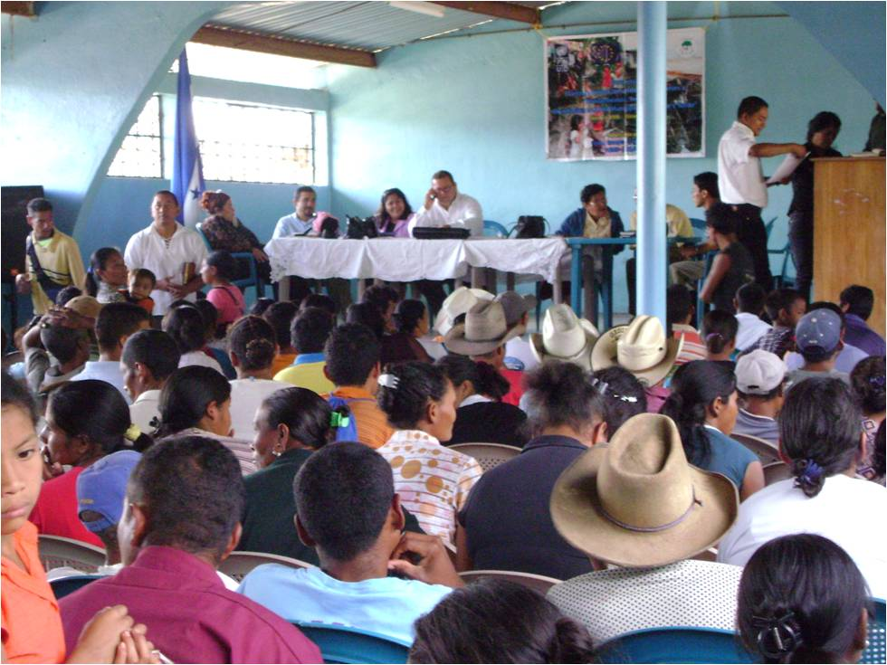

Local emergency comitees in Yorito take an oath.

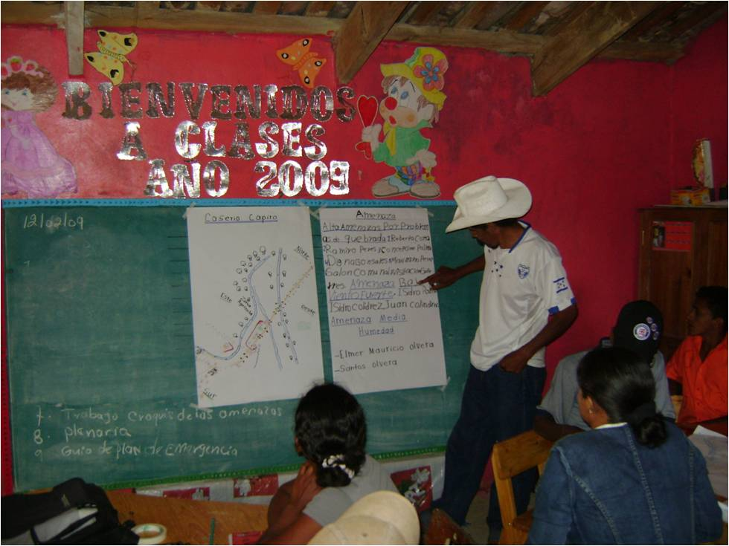

Worshop the community and the desasters in Mina Honda, Yorito.

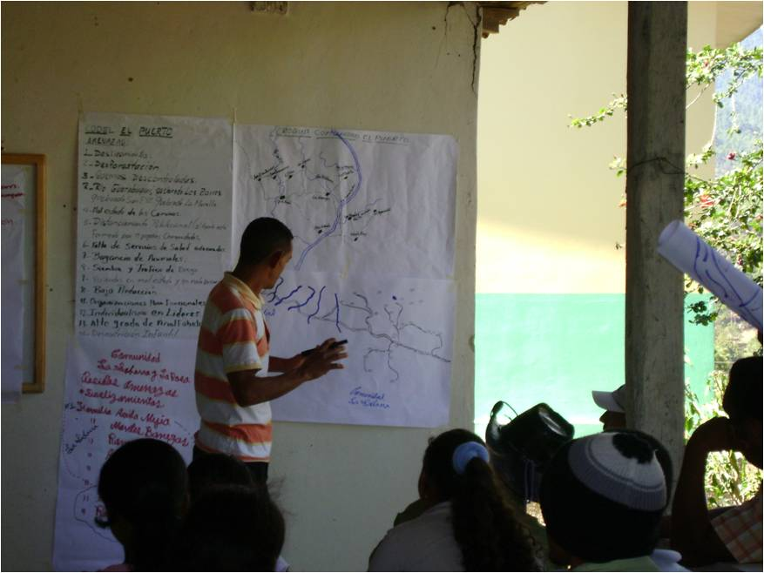

Preparing community emergency maps.

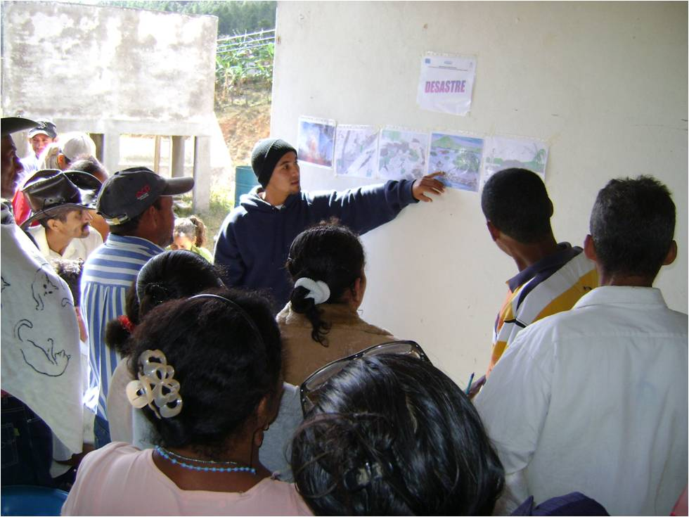

Explaing risk management concepts.

1. At proposal stage fill the numbered paragraphs, except those which start with [INT] (to be filled in at intermediate report stage) or with [FIN] (to be filled in at final report stage). At intermediate and final report stage, modify only key data in the numbered paragraphs (using strikethrough).
2. UNDP Human Development Report 2006.
3. This table will be annex I of the signed Agreement. It has to give a comprehensive overview of the different elements of the Action. It will only contain concise information on results and activities. Any changes made to the log-frame at intermediate report or final report stage will be done using strikethroughs.
4. Per result identified in the log-frame, more detailed information necessary for a good understanding of the proposal/ report will be completed here. A specific sub-section per result at proposal, intermediate report and final report stage has been foreseen (don't update information from a previous stage in this section, comment the change in the appropriate sub-section of the result). See also the guidelines for more information (e.g. for the list of sectors and related sub-sectors).  
   Also the main foreseen procurement procedures will have been identified (as well as in section 4.4 – work plan)
5. CENICAC: Centro Nacional de Investigación y Capacitación en Contingenias (National Centre for Research and Training of Contingencies) is part of COPECO internal structure.
6. The main means and costs (the sum of the indicated costs has thus not to be equal to the total amount for that result) have to be identified to ease understanding how the results will be reached and the activities implemented.
7. Update and explanation to be provided on progress as well as on changes made to the proposal.
8. Actualmente no está operando oficialmente como tal pero existe un vínculo entre los especialistas que la conforman.
9. The last table groups the costs that have not been dedicated to one specific result (support costs, feasibility studies, audits etc. as explained in the guidelines). The total of the total amount mentioned per result and in this table will correspond to the subtotal direct eligible costs in the table section 11.
10. Sustainability and connectedness are similar concepts used to ensure that activities are carried out in a context that takes longer-term and interconnected problems into account.
11. Expat, local staff, staff of the implementing partner,…
12. This table will constitute annex II of the signed Agreement.
13. The partner can use another representation of costs in line with the current practice in its organisation. These headings will become the chapters of the final financial reporting. In case personnel costs and the costs on information, communication and visibility are not explicitly available in section 4.3.2, these have to be explicitly mentioned in this table.